Supplementary Materials for

**Slide-seq: A Scalable Technology for Measuring Genome-Wide Expression at High Spatial Resolution**

Samuel G. Rodriques1,2,3†, Robert R. Stickels3,4,5†, Aleksandrina Goeva5, Carly A. Martin5, Evan Murray5, Charles R. Vanderburg5, Joshua Welch5, ­Linlin M. Chen5, Fei Chen*5††, Evan Z. Macosko*5,6††

* correspondence to: [chenf@broadinstitute.org](mailto:chenf@broadinstitute.org), emacosko@broadinstitute.org

† These authors contributed equally to this work.

†† These authors contributed equally to this work.

**This PDF file includes:**

Materials and Methods

Figures S1-S15

Tables S1-S3

Supplementary References

**Materials and Methods:**

***Beads:***

Bead barcodes were synthesized by the ChemGenes Corporation on one of two polystyrene supports (Agilent PLRP-S-1000A 10 μm particles or 10 μm custom polystyrene from AMBiotech**)**. Oligonucleotide synthesis was performed as described for Drop-seq(1). Beads were used with one of the two following sequences:

Sequence 1:   
5’- PEG Linker- TTTT-PC-GCCGGTAATACGACTCACTATAGGGCTACACGACGCTCTTCCGATCTJJJJJJTCTTCAGCGTTCCCGAGAJJJJJJJNNNNNNNNT30

Sequence 2:

5’- Linker-TTTTTTTTCTACACGACGCTCTTCCGATCTJJJJJJJJTCTTCAGCGTTCCCGAGAJJJJJJJNNNNNNNNT30

“PC” designates a photocleavable linker; “J” represents bases generated by split-pool barcoding, such that every oligo on a given bead has the same J bases; “N” represents bases generated by mixing, so every oligo on a given bead has different N bases; and “T30” represents a sequence of 30 thymidines.

***Puck Preparation****:*

Pucks were prepared in batches of 20 to 30, which were then stored dehydrated at 4C. Glass coverslips (Bioptechs, 40-1313-0319) were attached to a miniature centrifuge (USA Scientific 2621-0016)using double sided tape. Subsequently, the coverslip was cleaned by spraying with 70% ethanol and wiping with lens paper (VWR 52846-007).A spray-on silicone (Techspray 2102-12S) formulation was then applied to the coverslip, the cover to the minifuge was closed, and the minifuge was turned on for 10 seconds to spin coat the silicone onto the glass. The minifuge was then turned off and the cover opened, and liquid tape (Performix 24122000)was sprayed onto the coverslip. The minifuge was again closed and turned on for 10 seconds. The coverslip was then carefully removed from the minifuge, and a gasket (3 mm diameter holes from Grace Biolabs, CW-50R-1.0) was placed on top of the coverslip and pressed down. Beads were pelleted and washed twice in 500ul ultrapure water (Thermofisher, 10977015), and resuspended to a final concentration of 100,000 beads/uL. 10 µl of bead solution was pipetted into each position on the gasket. The coverslip-gasket filled with beads centrifuged at 40C, 850g for at least 30 minutes until the surface was dry.

The gasket was carefully removed from the dried coverslip. Gentle pipetting of water directly onto the pelleted beads removed all beads except for those directly in contact with the liquid tape layer. The resulting bead monolayer was allowed to dry, generating the final puck. Beads removed in this way could be stored at 4C for later use. As much water was removed from the resulting pucks as possible, and the pucks were left to dry.

***Puck Sequencing****:*

Puck sequencing was performed using SOLiD chemistry in a Bioptechs FCS2 flow cell using a RP-1 peristaltic pump (Rainin), and a modular valve positioner (Hamilton MVP). Flow rates between 1mL/min and 3mL/min were used during sequencing. Imaging was performed using a Nikon Eclipse Ti microscope with a Yokogawa CSU-W1 confocal scanner unit and an Andor Zyla 4.2 Plus camera. Images were acquired using a Nikon Plan Apo 10x/0.45 objective. After each ligation, images were acquired in the following channels: 488nm excitation with a 525/36 emission filter (MVI, 77074803); 561nm excitation with a 582/15 emission filter (MVI, FF01-582/15-25); 561nm excitation with a 624/40 emission filter (MVI, FF01-624/40-25); and 647nm excitation with a 705/72 emission filter (MVI, 77074329). The final stitched images were 6030 pixels by 6030 pixels.

Sequencing consisted of three steps: (1) primer hybridization; (2) ligation; and (3) stripping. During primer hybridization, a primer was flowed into the flow cell at 5 µM concentration in 4x SSC for 20 minutes. Subsequently, the flow cell was washed in 3 mL of SOLiD buffer F. Following buffer F wash, ligation mix (recipe below) was flowed into the chamber and allowed to sit for 20 minutes, before being flowed back into its original reservoir. Ligation mix was reused for ~10 ligations before being replenished. Following ligation, the flowcell was washed again in buffer F. Then, to cleave the fluorophore off the ligated SOLiD oligo, we flowed 1.5 mL of SOLiD buffer C into the chamber, followed by 1.5 mL of SOLiD buffer B, and repeated this cleave step once again. We then washed the flowcell in buffer F and repeated the ligation step. After the second ligation step, 10 mL of 80% formamide in water was flowed into the flowcell and left for 10 minutes. The flowcell was then washed in instrument buffer, and the process repeated with the next primer.

In order to sequence bead barcodes, we performed 2 ligations on each of 10 primers (Table S1), of which 6 were “constant” bases (i.e., the first ligation on a primer recessed by 2 or more nucleotides, which only sequence the primer and thus contain no information about the barcode sequence). The final bead barcodes were 14 bases long.

Each 3mm puck presented in this manuscript consists of roughly 70,000 beads, with a total cost of less than $0.10. Moreover, roughly 250uL of SOLiD SR-75 sequencing oligo is required to sequence a batch of 30 pucks. With other necessary reagents, each 3 mm puck requires roughly $10 of SOLiD sequencing reagents. However, each 3mm puck also requires roughly 300 million reads, or ~$200-$500 worth of sequencing using the Illumina Novaseq platform. Thus, the dominating cost of Slide-seq is the cost of short-read sequencing.

Ligation mix:

1x T4 DNA Ligase Buffer (Enzymatics)

6 U/uL T4 DNA Ligase (Rapid) (Enzymatics)

40x dilution of SOLiD SR-75 sequencing oligo (Life Technologies).

***Image Processing and Basecalling****:*

All image processing was performed using a custom-built processing suite in Matlab. Briefly, we acquired one image per puck after each ligation, and each image contained four color channels. First, color channels were co-registered to each other by thresholding the images and maximizing the cross-correlation between the thresholded images. Subsequently, for each puck, the images of each ligation were registered to the image of the first ligation using a SIFT-RANSAC image registration algorithm based on the VLFeat SIFT package in Matlab (*30*). Registered images were then base-called on a pixel-wise basis, as follows. First, the intensities in the Cy3 channel were multiplied by a factor of 0.5 and subtracted from the intensities in the TxR channel, which accounts for crosstalk between the channels resulting from the excitation of TxR using the 561nmlaser. Furthermore, for even-numbered ligations, the image of the previous ligation was multiplied by a factor of 0.4 and then subtracted on a channel-by-channel basis from the image of the even ligation. Each pixel was then called by intensity. For pucks made using the 180402 bead batch, we further enforced the expected base balance by including an additional step in which the intensities of the dimmest channels were progressively increased until each channel accounted for between 20% and 30% of the pixels in the center of the image.

Beads were subsequently identified from the base-called images as follows. Each pixel was assigned a number, the base 5 representation of which corresponds to the bases that were called at that pixel on each ligation. Every such number that occurred on at least 50 connected pixels in the image was determined to be a bead, represented by the centroid of the connected cluster.

SOLiD barcodes were then mapped to Illumina barcodes using a custom-built Matlab application that identifies the pairwise distance between all members of the two sets of barcodes. Pairs of SOLiD  and Illumina barcodes were saved for further analysis if: (1) the two barcodes were separated by at most two Levenshtein distance units; (2) there were at least 10 transcripts identified in Illumina sequencing with that barcode; and (3) the mapping between the barcodes was unique, i.e. if there were no other barcodes at equal or lower edit distance to either barcode.

***Tissue Handling****:*

Fresh frozen tissue was warmed to -20 C in a cryostat (Leica CM3050S) for 20 minutes prior to handling. Tissue was then mounted onto a cutting block with OCT and sliced at a 5° cutting angle at 10 µm thickness. Pucks were then placed on the cutting stage and tissue was maneuvered onto the pucks. The tissue was then melted onto the puck by moving the puck off the stage and placing a finger on the bottom side of the glass. The puck was then removed from the cryostat and placed into a 1.5 mL eppendorf tube. The sample library was then prepared as below. The remaining tissue was re-deposited at -80 C and stored for processing at a later date.

***Library preparation****:*

*RNA Hybridization:*

Pucks in 1.5 mL tubes were immersed in 200 µL of hybridization buffer (6x SSC with 2 U/µL Lucigen NxGen RNAse inhibitor) for 15 minutes at room temperature to allow for binding of the RNA to the oligos on the beads.

*First Strand Synthesis*

Subsequently, first strand synthesis was performed by incubating the pucks in RT solution for 1 hour at 42 C.

RT solution:

75 µL H2O

40 µL Maxima 5x RT Buffer (Thermofisher,EP0751**)**

40 µL 20% Ficoll PM-400 (Sigma, F4375-10G)

20 µL 10 mM dNTPs (NEB N0477L)

5 µL RNase Inhibitor (Lucigen 30281)

10 µL 50 µM Template Switch Oligo **(**Qiagen #339414YCO0076714)

10 µL Maxima H- RTase (Thermofisher, EP0751)

*Tissue Digestion:*

200 µL of 2x tissue digestion buffer was then added directly to the RT solution and the mixture was incubated at 37C for 40 minutes.

2x tissue digestion buffer:

200 mM Tris-Cl pH 8

400 mM NaCl

4% SDS

10 mM EDTA

32 U/mL Proteinase K (NEB P8107S)

*Library Amplification*

The solution was then pipetted up and down vigorously to remove beads from the surface, and the glass substrate was removed from the tube using forceps and discarded. 200 µL of Wash Buffer was then added to the 400 µL of tissue clearing and RT solution mix and the tube was then centrifuged for 3 minutes at 3000 RCF.The supernatant was then removed, the beads were resuspended in 200 µL of Wash Buffer, and were centrifuged again. After repeating this procedure an additional 2 times, the beads were moved into a 200 µL PCR strip tube, pelleted in a minifuge, and resuspended in 200 µL of water. The beads were then pelleted and resuspended in library PCR mix and PCR was performed.

Wash Buffer:

10 mM Tris pH 8.0

1 mM EDTA

0.01% Tween-20

Library PCR mix:

23 µL H2O

25 µL of 2x Kapa Hifi Hotstart ready mix (Kapa Biosystems KK2601)

1 µL of 100 µM Truseq PCR handle primer (IDT)

1 µL of 100 µM SMART PCR primer (IDT)

PCR program:

95 C 3 minutes

4 cycles of:

98 C 20 s

65 C 45 s

72 C 3 min

9 cycles of:

98 C 20 s

67 C 20 s

72 C 3 min

Then:

72 C 5 min

4 C forever

*PCR cleanup and Nextera Tagmentation*

The PCR product was then purified by adding 30 µL of Ampure XP (Beckman Coulter A63880) beads to 50 µL of PCR product. The samples were cleaned according to manufacturer's instructions and resuspended into 10 µL of water. 1 µL of the library was quantified on an Agilent Bioanalyzer High sensitivity DNA chip (Agilent 5067-4626). Then, 600 pg of PCR product was taken from the PCR product and prepared into Illumina sequencing libraries through tagmentation with Nextera XT kit (Illumina FC-131-1096).Tagmentation was performed according to manufacturer's instructions and the library was amplified with primers Truseq5 and N700 series barcoded index primers. The PCR program was as follows:

72°C for 3 minutes

95°C for 30 seconds

12 cycles of:

95°C for 10 seconds

55°C for 30 seconds

72°C for 30 seconds

72°C for 5 minutes

Hold at 10°C

Samples were cleaned with AMPURE XP (Beckman Coulter A63880) beads in accordance with manufacturer’s instructions at a 0.6x bead/sample ratio (30 µL of beads to 50 µL of sample) and resuspended in 10uL of water. Library quantification was performed using the Bioanalyzer. Finally, the library concentration was normalized to 4nM for sequencing. Samples were sequenced on the Illumina NovaSeq S2 flowcell with 12 samples per run (6 samples per lane) with the read structure 42 bases Read 1, 8 bases i7 index read, 50 bases Read 2. Each puck received approximately 200-400 million reads, corresponding to 3,000-5,000 reads per bead.

***Calculation of Bead Packing****:*

To estimate the packing fraction of the beads, we imaged 10 pucks with 488 nm light on the same microscope mentioned above after deposition onto the surface and prior to in situ sequencing. The signal was normalized to background and the image was binarized. The percent packing was reported as the fraction of the image occupied by the beads divided by the theoretical packing fraction of 0.9069 for dense packing of uniform spheres on a 2D surface. The mean and standard deviation of packing are reported in Fig. S1D.

***Clustering Analysis:***

For clustering of the pucks shown in Fig. 1C,D and S2, highly variable genes were identified by running FindVariableGenes() in the Seurat package in R, using a y.cutoff of 0.7 in liver, 0.6 in kidney and olfactory bulb, and 0.5 in hippocampus and cerebellum. For the hippocampus and cerebellum analyses, variable genes identified from the published datasets from these tissues were also included. Non-negative matrix factorization was performed using the NNLM package in R, on standardized, log-transformed values, with a k of 8 in liver and kidney, 6 in olfactory bulb, 13 in cerebellum, and 20 in hippocampus. For each bead, the largest factor loading from NMF after L2 normalization was used to assign cluster membership.

***Diffusion Analysis and Comparison of smFISH, scRNAseq and Slide-seq****:*

An image of Slide-seq bead signal density was generated through plotting the pixel intensity of each bead as a linear representation of the number of UMIs captured (180602_17, 180602_20, 180611_6). Single molecule FISH was performed on the serial section using HCR v3.0 (Molecular Technologies) with probes against three strong CA1 markers (*Slc17a7, Ociad2, Atp2b1)* and co-stained with DAPI. Images were taken of the tissue sections and profile was taken across a region of CA1 for the Slide-seq image, the DAPI image, as well two of the three genes (*Slc17a7*, *Atp2b1*) used in the FISH data. The full width half maximum (FWHM) of the profile was then calculated for 10 such profiles across the CA1 for both Slide-seq and the serial tissue sections in both DAPI and FISH (Fig. S5).

To quantify the efficiency of mRNA capture, we compared the counts of these genes in Slide-seq, scRNAseq and smFISH. FISH images were taken using a 40x 1.15 Nikon Plan Apo water immersion objective. Two fields of view (FoV, 652 µm x 652 µm) were imaged across CA1 for each of the genes tested (*Slc17a7, Ociad2, Atp2b1)* for each of the pucks for a total of six regions. Transcript counts for smFISH data were obtained by using StarSearch (rajlab.seas.upenn.edu/StarSearch/). Slide-seq data from the same FoV on the puck corresponding to the serial section was counted for the same marker genes (*Slc17a7, Ociad2, Atp2b1)*. Using the DAPI image for each of the FoV in CA1, we estimated the number of cells present in the FoV. Finally, a random sample of CA1 neurons from Drop-seq was taken equal to the number of cells present in the field of view and the sums for the three genes listed were taken across all single cell barcodes. The result of the total counts is shown as a bar plot (Fig. S4E) highlighting the differences in counts between the technologies.

***Comparison to Bulk sequencing****:*

To compare the capture of Slide-seq to bulk RNAseq dat (Fig. S4C), we used a stranded mRNA Truseq kit (Illumina #20020594) to prepare stranded PolyA selection libraries from a dissected sagittal mouse hippocampus. The libraries were sequenced and transcripts per million (TPM) for each gene were generated using Salmon post alignment with STAR (*31*). For Slide-seq data, average transcripts per million (APTM) was computed by summing counts for each gene, across all beads on a puck, and dividing by the sum of all UMIs on the puck, and dividing by 1 million (total UMI count/1million). The per-gene distribution for each of these values (bulk TPM and Slide-seq ATPM) was plotted and linear regression was performed giving an R = 0.89.

***Comparison to scRNAseq****:*

To compare the capture of Slide-seq to scRNAseq, as in Fig S4A,B,D, we extracted cells assigned to the CA1 cluster from hippocampal atlas data (*9*). For five hippocampal pucks (180531_13, 180531_17, 180531_22, 180602_20, and 180620_4) we isolated beads in CA1 by hand cropping. We then plotted the distributions of the number of transcripts per bead for each of the three genes considered (*Slc17a7*, *Atp2b1*, and *Ociad2*), and the total number of transcripts per bead, for the atlas (S4A) and Slide-seq (S4B) data. Fig. S4D was likewise generated by plotting the mean expression per bead in the atlas CA1 data against the mean expression per bead in the Slide-seq CA1 region for every gene in both the atlas and Slide-seq datasets. Note that for S4A,B,D, expression levels for Slide-seq are averaged over the 5 pucks listed above.

***Calculation of UMI per cell estimates:***

For calculation of the total UMIs captured normalized to total cells in Fig. S3D and S4F, we used DAPI images of serial stained tissue sections to estimate the total number of cells within a puck. Segmentation was performed in ImageJ by first scaling signal to background and binarizing the image followed by applying a 1.5 µm Gaussian Blur and a watershed transform. Nuclei were counted only if they had a diameter greater than 2 µm and less than 12 µm. The total number of UMIs from the puck was then divided by the number of nuclei obtained to generate the statistic total transcripts/ total cells.

***Cell Type Deconvolution (NMFreg)****:*

For each bead, the contribution of each cell type to the RNA on that bead was computed using a custom method, implemented in Python, termed NMFreg (Non-Negative Matrix Factorization Regression).  The method consisted of two main steps: first, single-cell atlas data previously annotated with cell type identities (*9*) was used to derive a basis in reduced gene space (via NMF), and second, non-negative least squares (NNLS) regression was used to compute the loadings for each bead in that basis.

To perform NMF on the single-cell data, highly variable genes were first selected as in (*9*), and NMF was performed using a specified number of factors (see below). Each factor was then assigned to the cell type whose cells from (*9*) most frequently had their largest loading on that factor. Next, for each Slide-seq bead, we first computed the bead loadings in the basis using NNLS. The resulting matrix of factor loadings (with dimensions of the number of beads by the number of factors) was scaled so each factor had unit variance. Finally, the cell type of the bead was assigned based on the identity of the maximum factor loading.

For the implementation of NMFreg in Figures 2B and 2C, an adult mouse single-cell cerebellum dataset (*9*)was used to define the NMF basis, using a *k* (factor number) of 25. The published cluster identities from this tissue were modified to remove clusters of cells outside of the Slide-seq-assayed anatomical region (e.g., cells from midbrain not seen on the puck) and to reduce the number of subpopulations. Specifically, all endothelial populations were merged together into one population, as were non-Bergmann astrocytes and oligodendrocytes. Interneurons not annotated as unipolar brush or Golgi (clusters 3-1, 3-2, 3-3, and 3-4)—which could not be assigned to a specific type in the published dataset—were also grouped together. Only Slide-seq beads with more than 15 unique genes were used in NNLS regression. For the implementation of NMFreg in Figure 2D, an adult hippocampus scRNA-seq dataset (*9*) was used in NMF setting *k* to 30 with 5 variable gene cutoff for bead inclusion. The first-level published cluster identities were used for bead assignment to cell types.

For the implementation of NMFreg in Figures 2D, 3 and 4, the data were processed using published cerebellum (*9*) (Figure 3) or hippocampus (*9*) (Figures 2D, 4) datasets. In Figs. 2D, 3, and 4, Slide-seq beads were used for NNLS regression if they had at least 5 variable genes. For Figure 4, hippocampus cluster 13 was interpreted as marking mitosis.

Often, multiple cell types may be present on a bead. Thus, for the purpose of calculating the number of cells of each type appearing on the puck, as in Fig. 2C and Fig. S7, we determined that a cell type was present on a bead if the L2 norm of the vector of factor loadings for that cell type was at least half of the L2 norm of the vector of all factor loadings for that bead. Fig. S7 shows the numbers plotted in Fig. 2C as a function of this cutoff.

***Confidence Thresholding:***

The bead factor loadings returned by NMFreg are in general less pure than the factor loadings obtained for single-cell sequencing data, possibly reflecting both the sparsity of the Slide-seq data and RNA contributions of other adjacent cell types. In Fig. S8, in order to determine whether a given bead could be confidently assigned to its highest contributing cell type, we computed a cell-type-specific, single-cell-derived threshold. The threshold for a given cell type was the maximum loading of this cell type among all single cells not assigned to this cell type in single cell atlas data. A bead was said to be confidently assigned if the L2 norm of the vector of factors corresponding to that cell type exceeded the threshold. This comparison was made after normalizing so that the sum of the L2 norms of the vector of factors for each cell type would be equal to 1.

For Fig. S8A-E, we first performed NMFreg using only beads with at least 100 total transcripts. This decreases the number of beads called by 72.6% +/- 13.7% (mean+/-std over 7 cerebellar pucks). Interestingly, there was no relationship between the number of UMIs per bead and the confidence score of the bead (Fig. S8F). Note that for the computation in Fig. S8F, NMFreg was performed on all bijectively mapped beads, which must have at least 10 transcripts.

The diameter of Slide-seq beads is 10 µm (original feature size). For the analysis in Fig. S8A-D, in an attempt to investigate the importance of the size of the features, we generated larger beads *in silico*, selecting artificial feature sizes of 20, 40, and 100 µm.  Aggregate array features were performed by taking bead centroid locations obtained through SOLiD sequencing and forming a grid of defined size over the locations of the beads and aggregating beads within each region of the grid and treating the resulting data as a single bead.

***Robustness of NMFreg:***

To evaluate the robustness of the NMFreg cell type assignments, we calculated a consistency metric (Fig. S6B,C) by running NMFreg for 30 values of *k* (the number of factors) between 18 and 48, or for 30 different random seeds. For each Slide-seq bead, the consistency was then defined as the fraction of NMFreg runs on which the bead was assigned to the most common cell type across conditions tested. These results were plotted as a cumulative distribution function of the consistency score per bead.

***3D volume reconstruction of hippocampus****:*

For Fig. 2D, beads assigned to hippocampus scRNA-seq clusters 4, 5, and 6 (CA fields and DG) (*9)* from serial hippocampal Slide-seq sections were plotted in space. Sequential slices were roughly aligned by the density and shape of beads localized to hippocampal morphology. Alignments were refined with the ImageJ plugin TurboReg (*32*). Volumes were reconstructed in 3D by generating a 3D image stack with a sphere of diameter 12.5 µm with intensity proportional to number of UMIs centered on each bead centroid.

***Hippocampal Subtype Images****:*

Metagenes for Fig 2E were identified from cell type specific atlas expression. The metagenes are listed in Table S2.

Metagenes were plotted via density plots (see below) on their corresponding Atlas clusters. Beads corresponding to hippocampal atlas clusters 4, 5, and 6 (CA1, CA2/3, and DG) were displayed in light gray as a counterstain.

***Density Plots:***

For the density plot images in Fig. 2E, 3 (black backgrounds), 4 (black backgrounds), S9E,F, S11A,C,F,G and S12, we formed an image as follows. Each point P in the 6030 x 6030 images was assigned an intensity equal to the sum of the intensities of all beads with centroids lying within 44-pixel square centered on P. For 4B,C, each bead assigned to the indicated NMFreg cluster was assigned a unit intensity, while the intensity for each bead in 3C,D,F,G was taken as the total number of transcripts belonging to genes in the indicated metagene. Finally, the images were passed through Gaussian filters with a standard deviation of 12 pixels.

For the images with blue backgrounds in Fig. 4, each bead was represented by a square of length 70 pixels on each side, with intensity equal to the total number of transcripts belonging to the set of genes indicated in the legend. Overlapping squares summed their intensities in the overlap region. For Fig. 4G-K, all the images within a given panel are normalized to the same values (i.e., the same colors represent the same values in all four images).

***Significant Gene Calling:***

To determine whether a transcript had a significantly non-random spatial distribution within a particular set of beads (for example, within the set of beads called as Purkinje neurons by NMFreg), we first calculated the matrix of pairwise Euclidean distances between all beads in the set. We then compared the distribution of pairwise distances between the beads expressing at least one count of that transcript (Fig. S10A) to the distribution of pairwise distances between an identical number of beads, sampled randomly from all mapped beads within the set with probability proportional to the total number of transcripts on the bead (Fig. S10B). (Rigorously, therefore, the spatial significance gene algorithm determines whether the spatial distribution of a particular transcript differs significantly from the spatial distribution of all transcripts.) Specifically, we generated 1000 such random samples, and for each sample calculated the distribution of pairwise distances. We then calculated the average distribution of pairwise distances, averaged across all 1000 samples (Fig. S10B, bottom). Finally, we calculated the L1 norm between the distribution of pairwise distances for the true sample of beads and the average distribution (Fig. S10C), and the L1 norm between the distribution of pairwise distances for each of the 1000 random samples and the average distribution (Fig. S10D). We defined *p* to be the fraction of random samples having distributions closer to the average distribution (under the L1 norm) than the true sample, and considered any genes with values *p*≤0.005 (Fig. S10E)*.* Often, as many as 4000 genes would pass the filters described above, leading to a high false-positive rate. For this reason, various methods were used to enrich for true positives (described in detail below), for example by using multiple biological replicates, or by identifying clusters of correlated genes within the set of spatially significant genes.

Genes were identified as spatially non-random using a custom Matlab application (see Fig. S10). In regions in which cells are densely packed, one often finds markers from multiple different cell types on a single bead. In some instances, when seeking to identify spatially patterned genes within a cell type, our algorithm identified markers of cell types in spatial proximity. For example, in cerebellum, granule cell markers were sometimes identified as spatially non-random within a set of oligodendrocytes due to the proximity of the granular layer and the cerebellar white matter. For this reason, genes were identified as candidates for the statistical significance analysis within a particular cluster if they had an average expression of at least 0.1 transcripts per bead within that cluster in the atlas reference dataset, or if the variance within that cluster in the atlas reference dataset was at least 0.01 transcripts squared and the ratio of the variance to the squared expression was at least 7.5 (an empirically determined value). Moreover, candidate genes for the statistical significance analysis were required to have at least one transcript on at least 15 beads in Slide-seq.

***Overlap Analysis:***

To identify genes that are significantly correlated or anticorrelated with other genes, we applied a custom Matlab algorithm. For simplicity of description, we consider the case of determining the genes that are correlated or anticorrelated with a particular gene, gene A. For each gene in the genome, we generated a “true” image in which each bead with at least one transcript of the gene was represented by a square of side length 100 pixels (~64 microns). Images were then binarized, so overlapping squares did not sum. Then, for each gene, we additionally generated 50 “random” images in which the same number of transcripts were redistributed across all beads with probability proportional to the number of reads per bead. We then calculated the pixel-wise inner product between the image of gene A and the 50 random images every other gene, and calculated the mean and standard deviation of the inner products. We then compared the mean and standard deviation to the inner products of the image for gene A with the true image of every other gene, obtaining a Z score for each gene. All genes with Z scores greater than 3 were deemed correlated, while those with Z scores less than 3 were deemed anticorrelated.

***Regional Significance Analysis:***

For several of the analyses in Fig. 3 and S11, we used the following procedure to determine whether the expression of a gene within a given region of the puck was significantly enriched or depleted. We divided Puck 180819_12 into 5 regions (Fig. S12): a dorsal region, a ventral region, a nodulus region, a nodulus-uvula region (consisting of the nodulus and the anterior uvula), and a VI-VII region, corresponding to the posterior side of lobule VI and the anterior side of lobule VII. The significance of a gene was then determined by a Fisher exact test performed on the contingency matrix [A, N-A; B, M-B], where A is the number of counts of the gene in the designated region, B is the number of counts outside of the designated region, N is the total number of counts of any gene in the designated region, and M is the total number of counts of any gene outside of the designated region. As in the case of the significant gene-calling algorithm, this analysis could be performed on a subset of the beads on the puck. This procedure provides a list of genes with a significantly different pattern of expression within the designated region than outside of the designated region, regardless of whether the expression is elevated or depressed.

In Fig. 3B, *Kctd12* and *Car7* did not pass the *p*-value cutoff, but are displayed as squares to demonstrate their location relative to *Aldoc*.

***Identification of spatially variable genes in the cerebellar granular layer:***

We identified *Gprin3* by finding all of the genes with significant expression (*p<*0.001, Fisher exact test) in the ventral part of puck 180819_12 compared to the dorsal part of the puck, for which more than 80% of the transcripts were in the ventral portion. This yielded three hemoglobin genes, *Th*, *Cemip, Gprin3, Mab21l2,* and *Syndig1l*. The three hemoglobin genes and *Th* were discarded because they were not expressed in granule cells.

***Identification of* Aldoc*- and* Plcb4*-associated genes in the cerebellar Purkinje layer:***

To identify the *Aldoc* and *Plcb4*-associated genes, we ran the significant gene calling algorithm on 14 cerebellar pucks (3 coronal, 11 sagittal), restricted to beads called as cluster 2 (Purkinje cells), cluster 7 (Bergmann glia), or the union of cluster 2 and 7 together. In this way, we identified 669 genes that were significant on at least one of pucks. This method presumably included many false positives, due to the high false discovery rate of the spatial significance algorithm. For that reason, we came up with the following procedure to restrict the set of spatially significant genes to those that correlated more with *Aldoc* than with *Plcb4*, or more with *Plcb4* than with *Aldoc*, on the grounds that false positives or genes unrelated to the Zebrin staining pattern would not correlate more with one than with the other. To identify genes correlating preferentially with *Aldoc* or *Plcb4*, we used the significance overlap algorithm to identify, for each of the 669 genes, the other genes in the set that correlate spatially with that gene on at least one puck. We then calculated, for each pair of genes in the set of 669, the magnitude of the intersection of the sets of correlating genes. To construct the matrix in Fig. 3A, we restricted that overlap matrix to the set of genes that have a larger intersection with *Aldoc* by at least 3 genes, or a larger intersection with *Plcb4* by at least 3 genes.

For the purposes of displaying the matrix thus obtained in Fig. 3A, we first normalized the *i,j*th entry of the matrix by dividing as follows:

$$p_{i,j}←\frac{p_{i,j}}{\sqrt{p_{i,i}p_{j,j}}}$$

We then divided each column of the resulting matrix by the sum of the column. Finally, because the resulting matrix was asymmetric, we summed the matrix and its transpose. For purposes of display, we then performed Ward clustering in Matlab and ordered them by cluster.

***Identification of* Hspb1 *pattern:***

To generate Fig. 3B, we included genes if they had significant expression in the nodulus-uvula region at p<0.001 (Fisher exact test). We excluded *Ttr*, which was not expressed in Purkinje cells. For purposes of display, *Kctd12* and *Car7* were added to the graph as squares to help illustrate the clustering of *Aldoc*-like genes and *Cck*-like genes.

***Identification of* B3galt5 *pattern:***

To generate Fig. S11E, we included genes if they had significant expression in the nodulus at p<0.05 (Fisher exact test) and significant expression in the VI-VII region at p<0.05 (Fisher exact test).

***Identification of injury-correlated genes:***

To identify all genes that correlated spatially with *Hba-a1*, *Hba-a2*, and *Hbb-bs*, we ran the overlap analysis on pucks 180819_1, 180819_2, 180819_3, 180819_4, 180819_13, 180819_14, and 180728_15. The first four pucks were taken from a single mouse in the coronal orientation, while the last three pucks were taken from a second mouse in the sagittal orientation. We considered all genes that correlated with at least one of those three genes on at least 2 pucks. The only genes identified in this way, besides hemoglobin, were *Lars2* (a marker of rRNA, see Identification of rRNA below) and *Fos*.

To identify genes correlating with *Vim*, *Ctsd*, or *Gfap* at the 3-hour timepoint (pucks 180819_16, 180819_18, 180819_19, and 180821_3) or the 2-week timepoint (pucks 180819_5, 180819_6, 180819_7, and 180819_8) (Table S2), we ran the overlap algorithm. All four pucks for each timepoint were taken from a single mouse in the sagittal orientation. The corresponding list in Table S2 is the set of all genes that correlate with at least one of *Vim*, *Ctsd*, or *Gfap* on at least two of the pucks.

***Distance Measurements for Injury Site:***

The distance measurements in Fig. 4D,E were performed by plotting beads in each of cluster of interest with radius linearly proportional to the number of transcripts per bead, with one transcript corresponding to a 25 pixel diameter and 500 transcripts corresponding to a 125 pixel diameter. Beads with more than 500 transcripts were plotted with a 125 pixel diameter. This was done to ensure that beads with more transcripts were weighted more heavily when calculating the spatial profile of the cell types. We then drew boxes around the injury and took line profiles (i.e., summed along one axis) across the injury site, to generate the profiles in 4D,E.

For measurements of the mitosis layer thickness, we took two measurements from one puck (Puck_180821_3, both sides of the injury site) and one measurement from a second puck (Puck_180819_19, the bottom side of the injury site). For measurements of the astrocyte scar thickness and the microglial penetration thickness, we took six measurements: two on each side of the scar from each of three pucks (Puck_180819_5, Puck_180819_6, and Puck_180819_7).

For the distance measurements in Fig. 4K, we plotted grayscale versions of the images in 4K using the IEG metagene listed in Table S2, and took line profiles similar to those taken for the measurements in Fig. 4D,E. We took measurements from each side of the injury for puck 180819_7 (4G, bottom). We additionally took measurements from one side of the injury on pucks 180819_5 and 180819_6. We only used one side from those pucks on the grounds that the injury site was very close to the edge of the puck on one side.

Two of the three-day injury pucks (180819_16 and 180819_18) were excluded from all distance measurements on the grounds that the tissue damage was not readily identifiable on the puck.

One two-week injury puck (180819_8) was excluded from all distance measurements on the grounds that the tissue slice was more lateral than the other tissue slices. It showed neither enrichment of the immediate early genes around the injury site, nor a dip in astrocyte density in the middle of the scar, leading us to suspect that it was at the edge of the wound.

***Identification of rRNA in pucks:***

During analysis of the 2-hour injury pucks, we observed many counts of the *Lars2* gene correlating with hemoglobins and *Fos* at the injury site (Fig. S14). Upon investigation of the *Lars2* gene, we found using RepeatMasker (<http://www.repeatmasker.org/>) that it has a rRNA-derived repeat in its 3’ UTR, leading us to hypothesize that the counts we observed of Lars2 might in fact be misaligned rRNA reads (*33*). Moreover, we found that the spatial distribution of *Lars2* counts across the puck is highly correlated to the counts of rRNA, supporting this hypothesis. We thus used *Lars2* as a proxy for rRNA expression in Fig. 4A.

***Staining and Validation of the Cortical Injury protocol:***

# To validate the cortical injury procedure in Fig. S13, we stained with (Abcam ab53554) against Glial Fibrillary Acidic Protein (*Gfap*), a marker of activated astrocytes and microglia that should be enriched near the site of injury. To further validate our finding of *Vim* as a gene strongly upregulated at the site of injury we also stained with (Abcam ab20346) against *Vim* showing that it is expressed precisely at the injury. Sections were sectioned at 10 μm and post fixed in 4% PFA for 10 minutes. Post fixation they were washed three times in PBS before being co-stained with the antibodies listed above for two hours at 37C. Post primary antibody incubation sections were washed three times for five minutes in 10 mL of 1x PBS. Sections were then stained with the appropriate secondary antibodies (Abcam ab150135 and ab175700) for one hour in 1XPBS. Sections were then washed three times for five minutes in 1X PBS and co-stained with DAPI and imaged using a 20x 0.75 Nikon Plan Apo objective.

# *Gene Ontology Analysis:*

# For Fig. 4G-J, we first identified (using the tool at <http://geneontology.org/>) gene ontology annotations that were significantly enriched within the set of genes that correlated with the injection site only at the 2 week timepoint or only at the 3 day timepoint (see “Identification of injury-correlated genes,” above). Each image in Fig. 4G-J is a heatmap showing the total gene counts summed over all genes in each annotation. For each of Fig. 4G-J, both heatmaps were normalized to the maximum value in either the top or bottom heatmap. Thus, the values shown for the 2-week and 3-day pucks are on the same scale, and the units are arbitrary.

# The annotation used for Fig. 4G was “mitotic cell cycle.” Fig. 4H was “antigen processing and presentation via MHC class Ib.” The annotation used for Fig. 4I was “gliogenesis.” The annotation used for Fig. 4J was “oligodendrocyte development.”

***Animal Handling:***

Animals were group housed with a 12-hour light-dark schedule. All procedures involving animals at MIT were conducted in accordance with the US National Institutes of Health Guide for the Care and Use of Laboratory Animals under protocol number 1115-111-18 and approved by the Massachusetts Institute of Technology Committee on Animal Care. All procedures involving animals at the Broad Institute were conducted in accordance with the US National Institutes of Health Guide for the Care and Use of Laboratory Animals under protocol number 0120-09-16.

***Traumatic Brain Injury Model:***

Animals for the TBI model were anesthetized and processed according to a standard intracranial injection protocol as a model for injury. Specifically, mice were anesthetized using isofluorane and stereotactically restrained. Subsequently, an incision was made in the scalp and a hole was made in the skull using a dental drill. A Hamilton needle (32 gauge, 7803-04) was lowered to 2 mm below the surface of the skull, and was then promptly retracted. The wound was closed using Vetbond, and the animal was allowed to recover. Mice were treated with Buprenorphine-SR and Meloxicam for analgesia. Mice were sacrificed by cardiac perfusion 2 hours, 3 days, or 2 weeks following the injury.

***Transcardial Perfusion:***Animals were anesthetized by administration of isoflurane in a gas chamber flowing 3% isoflurane for 1 minute. Anesthesia was confirmed by checking for a negative tail pinch response. Animals were moved to a dissection tray and anesthesia was prolonged via a nose cone flowing 3% isoflurane for the duration of the procedure. Transcardial perfusions were performed with ice cold pH 7.4 HEPES buffer containing 110 mM NaCl, 10 mM HEPES, 25 mM glucose, 75 mM sucrose, 7.5 mM MgCl2, and 2.5 mM KCl to remove blood from brain and other organs sampled. The appropriate organs were removed and frozen for 3 minutes in liquid nitrogen vapor and moved to -80C for long term storage.

***Human Sample Information:***

Human cerebellum tissue assayed in Fig. S3 was obtained from the Sepulveda Research Corporation through the NIH NeuroBioBank. The tissue was received without identifiable information, and did not meet the definition of human subjects research (project # NHSR-4235).

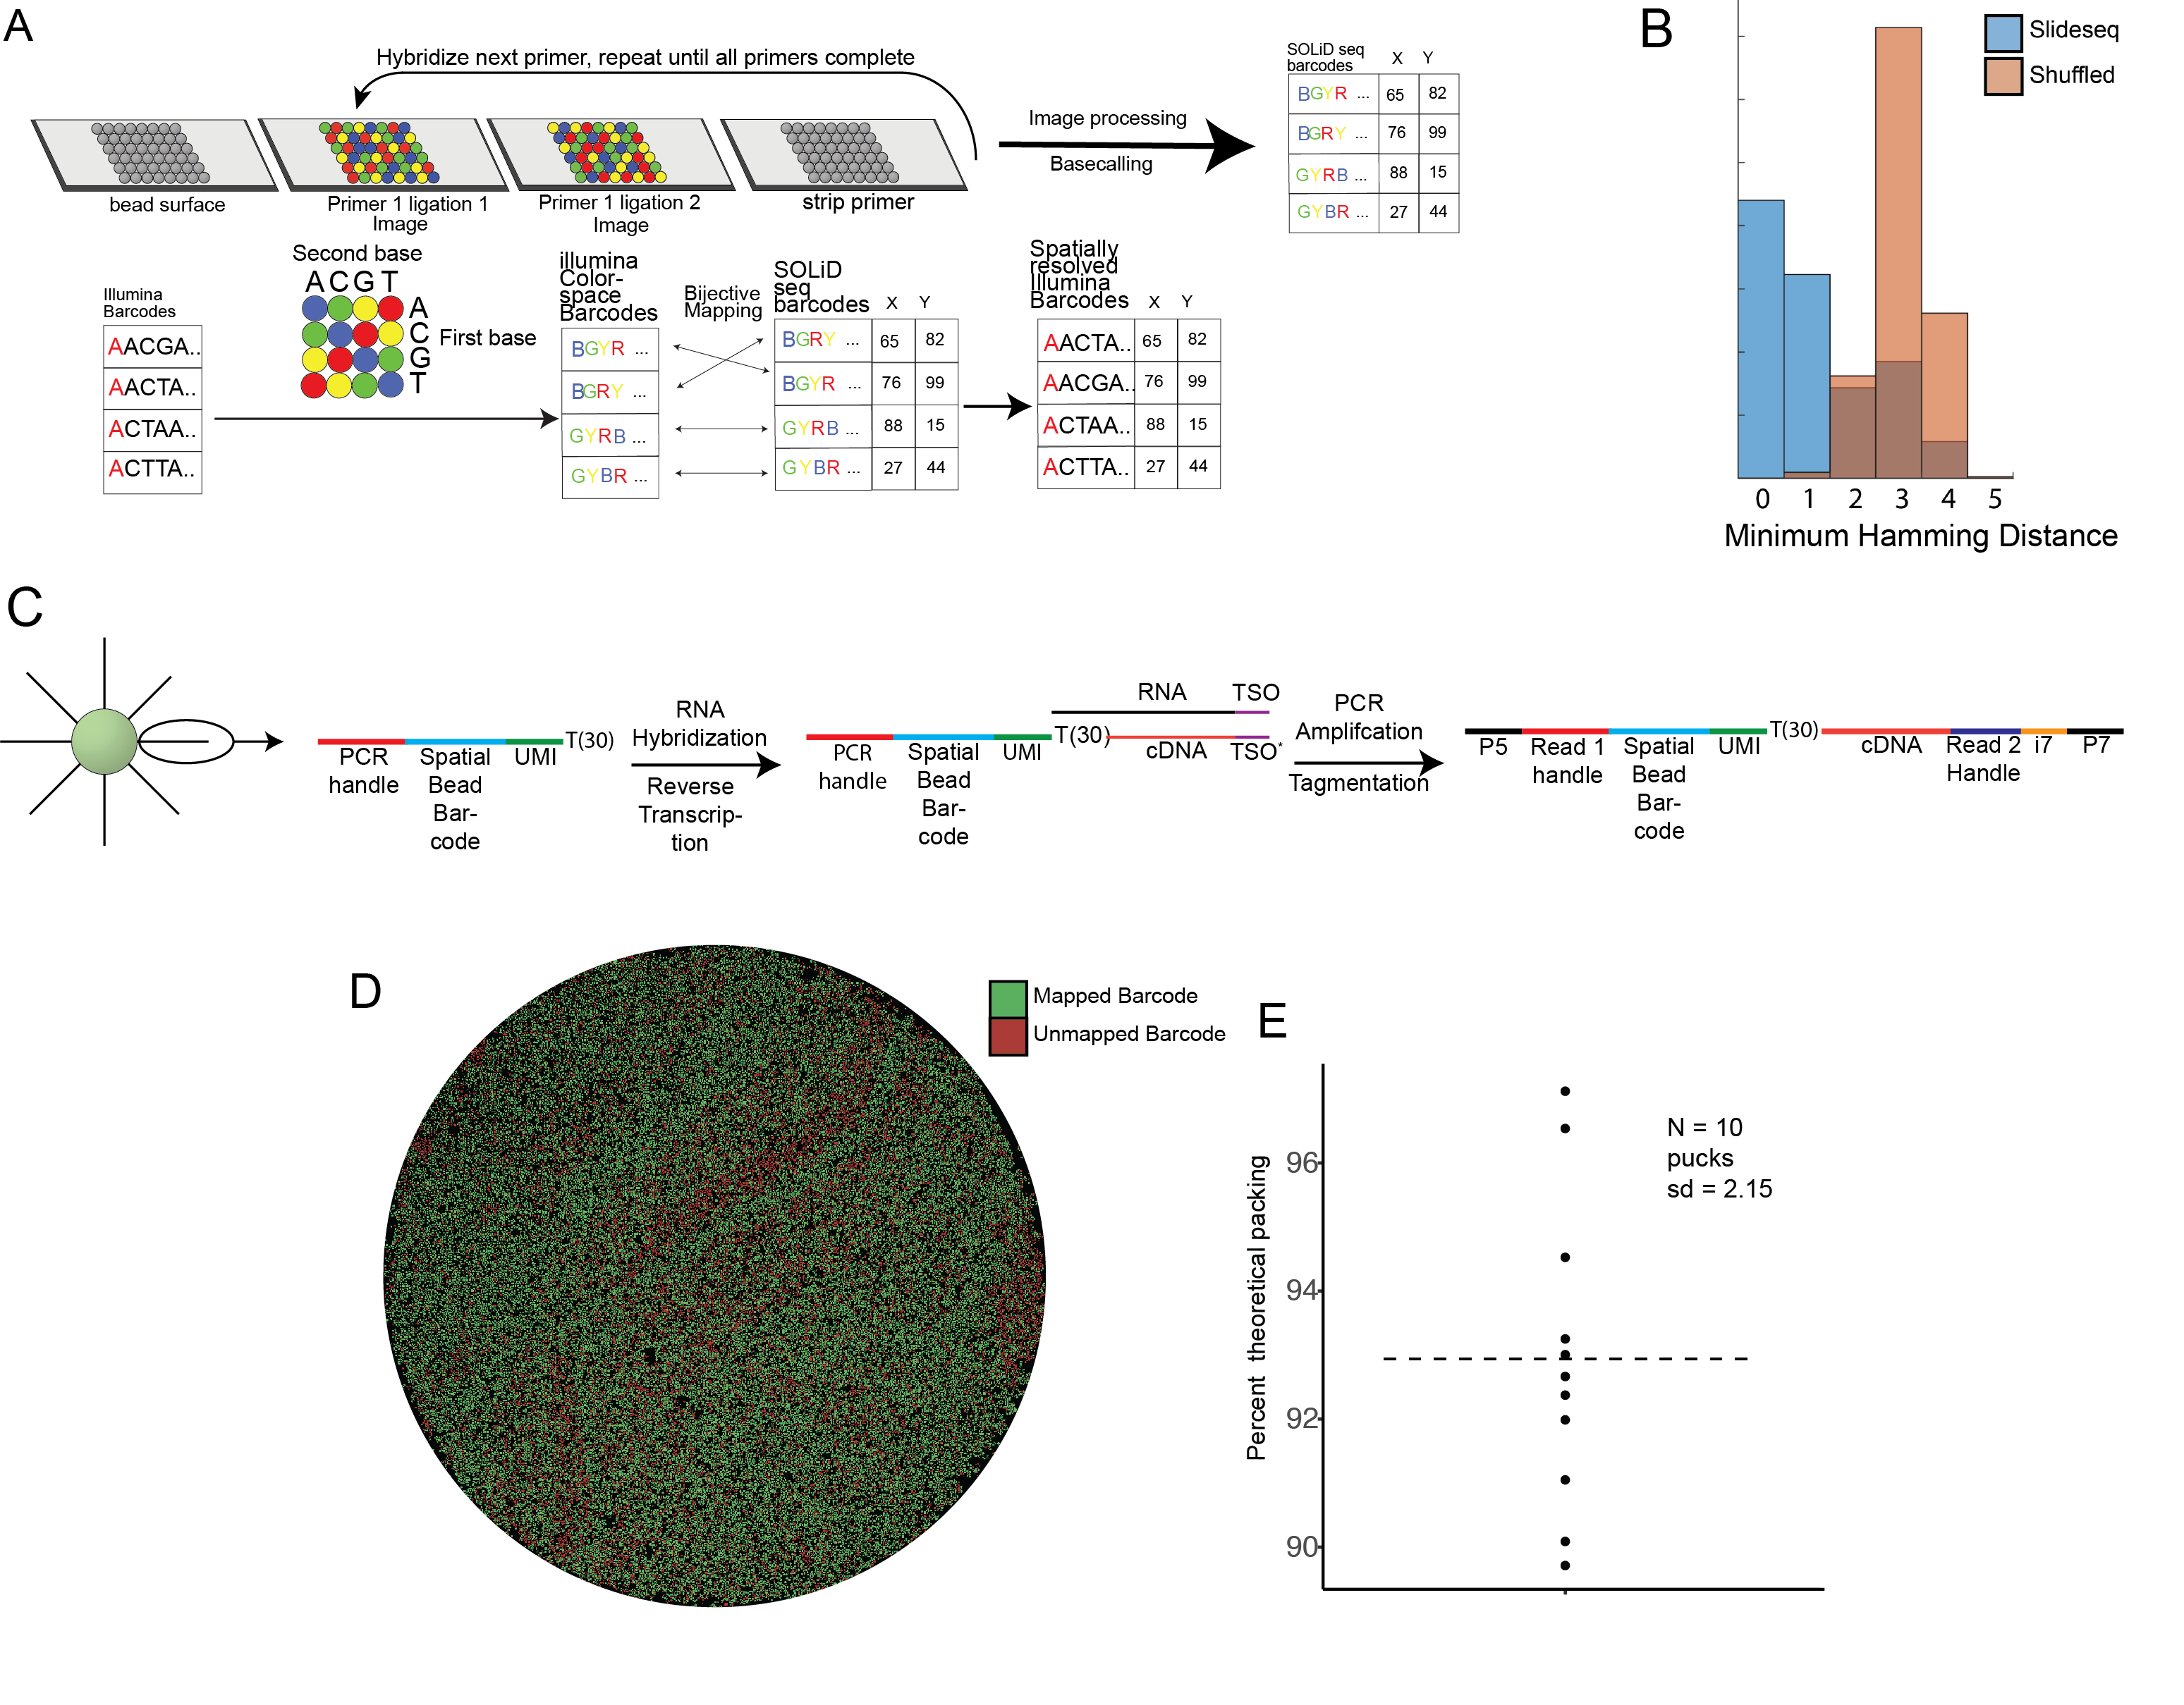**Figure S1:** (**A**)Top: schematic of the *in situ* sequencing and base-calling system established for generation of barcoded surfaces (“pucks”). Bottom: schema for mapping of Illumina barcodes to SOLiD barcodes.  (**B**) Minimum hamming distance between Illumina colorspace-converted barcodes and barcodes from a puck sequenced *in situ* using SOLiD chemistry (Blue, puck barcodes, Orange, shuffled puck barcodes). (**C)** Structure of the library at each stage of the preparation. (**D**) Barcode mapping across the puck. Beads colored green have a barcode bijectively matched between Illumina and SOLiD sequencing. Red beads are SOLiD-called barcodes not detected by Illumina sequencing. (**E**) Beanplot shows the packing fraction of the beads on the surface, as a fraction of the maximum theoretical density. The average packing fraction is 85%, which is 93% of the theoretical maximum.

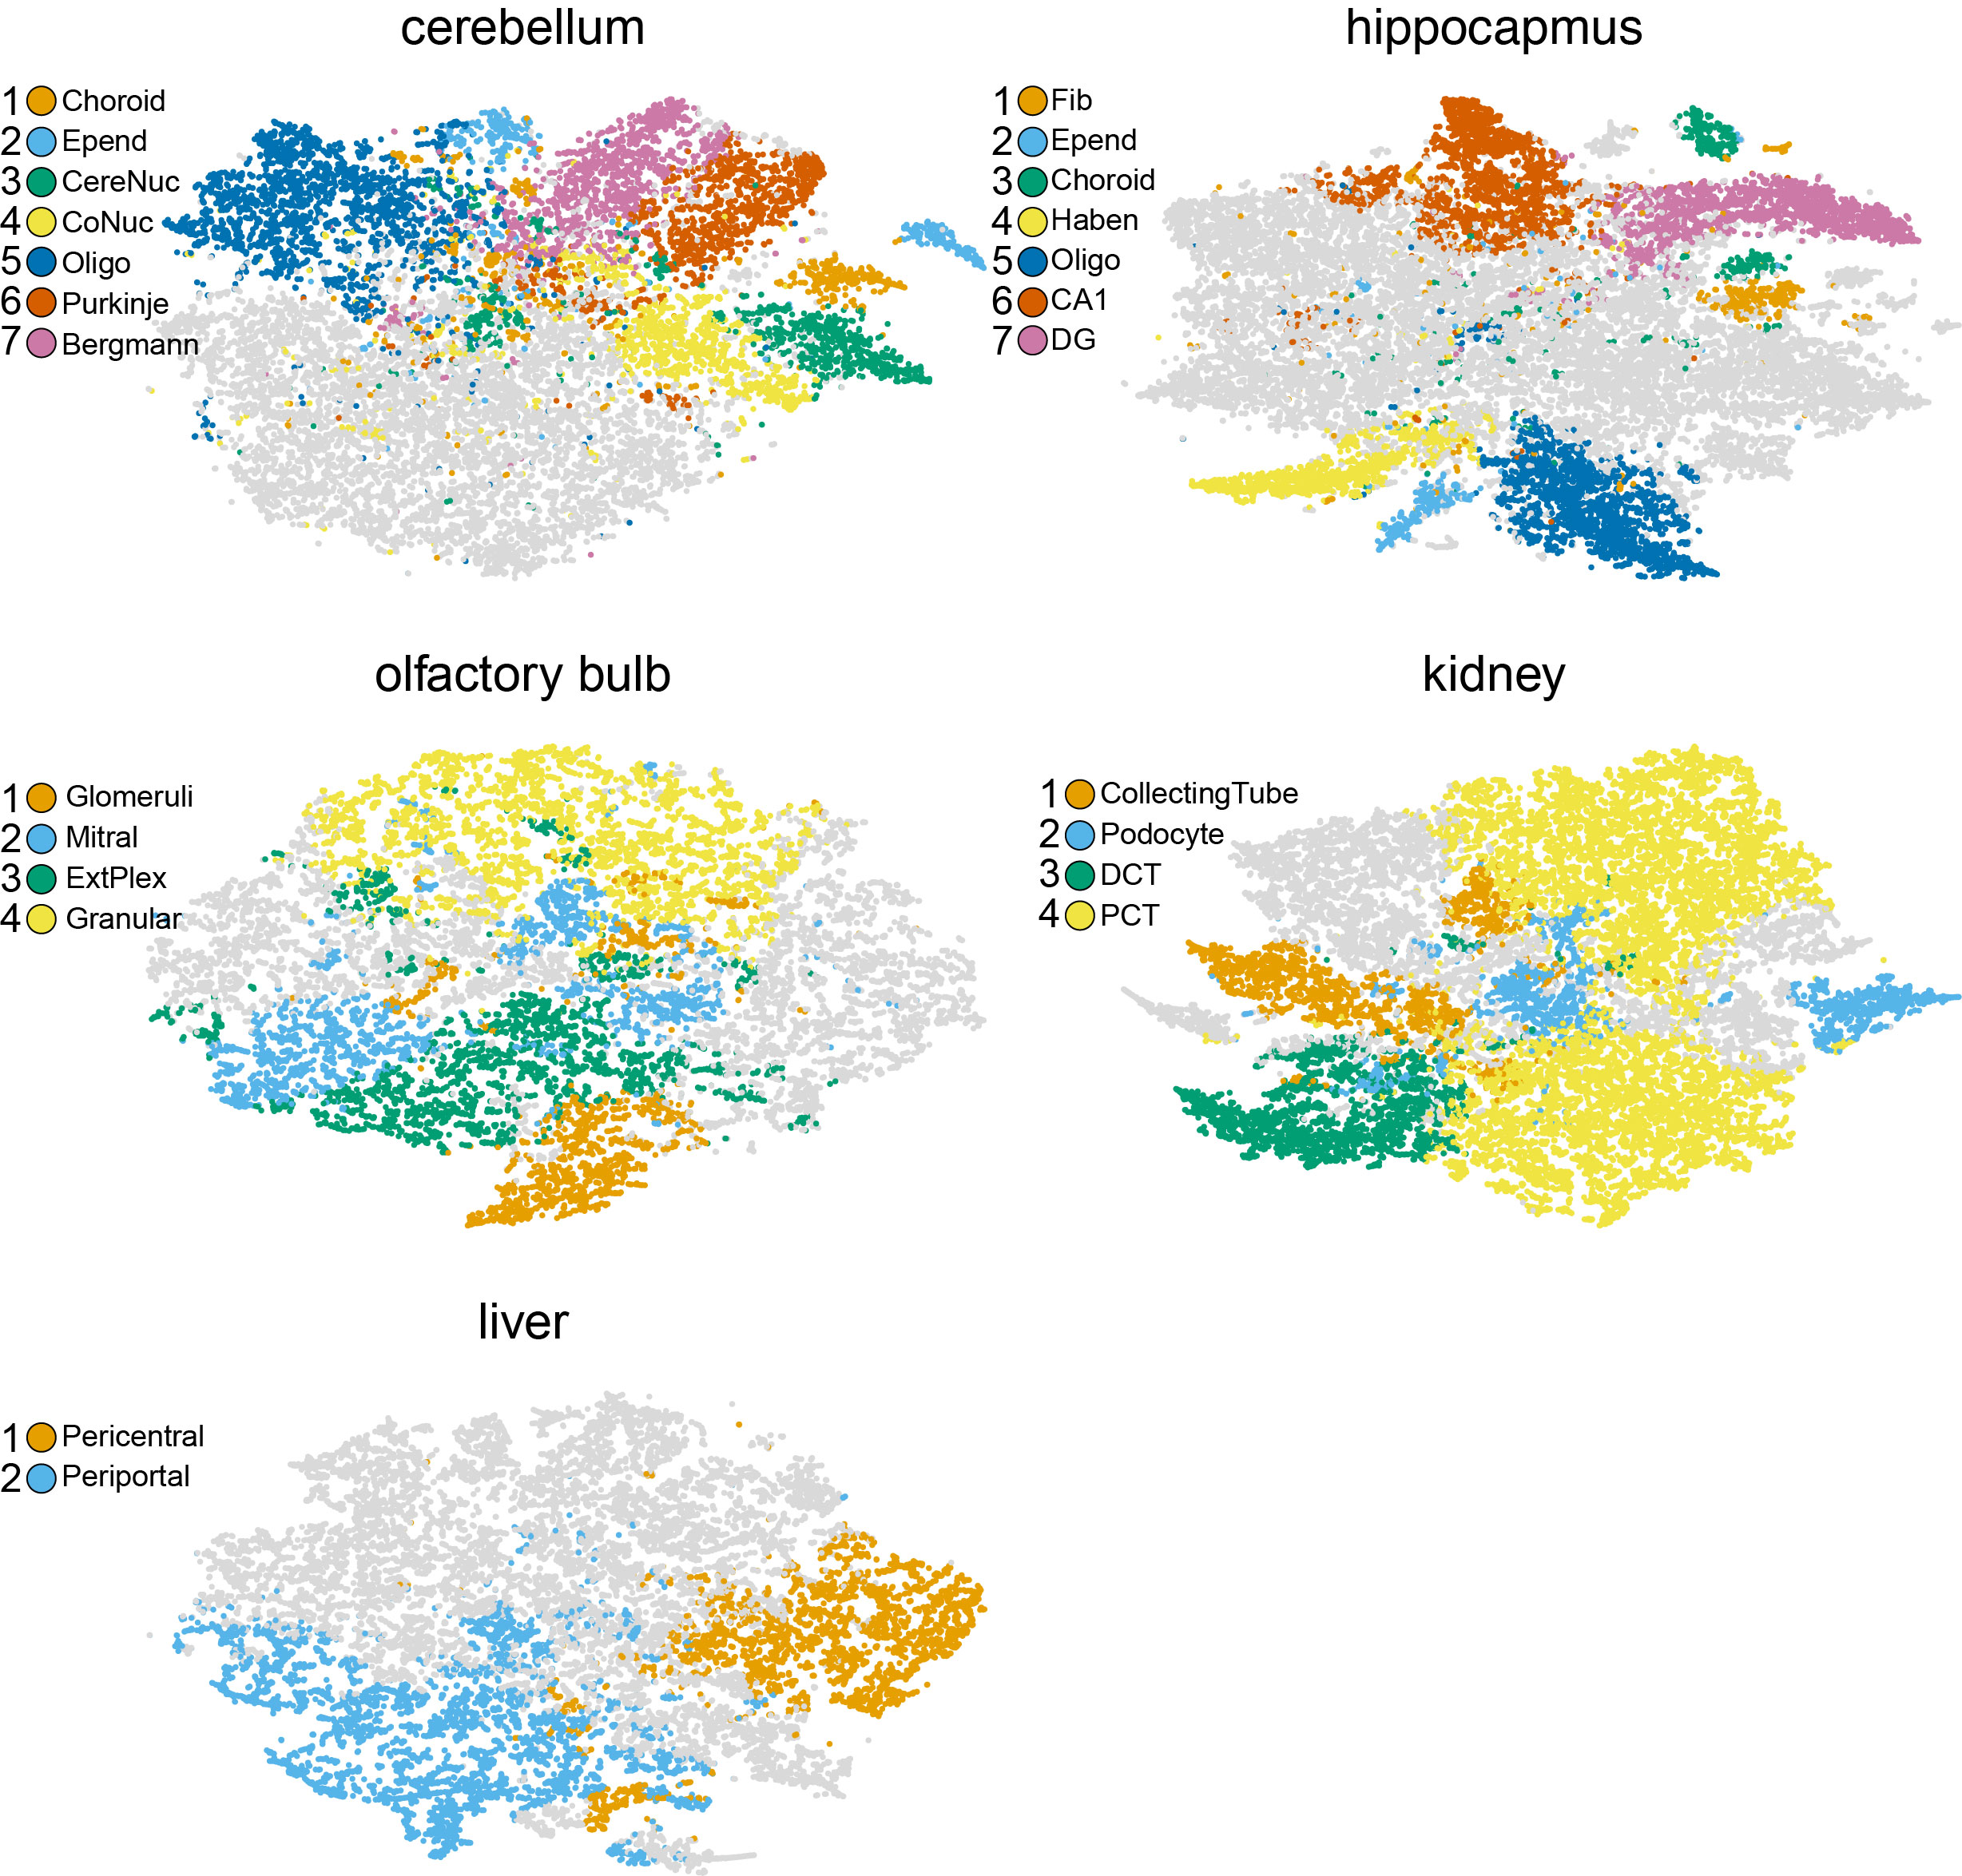

**Figure S2: Paired tSNE from Slide-seq data for various tissue types:** Shown are tSNE embeddings of the tissues assayed in Fig 1C. Coloring of clusters is consistent with Fig 1C. Cluster identities were annotated as follows: Cerebellum: (1) Choroid plexus (2) Ependymal (3) cerebellar nucleus neurons (4) Cochlear nucleus (5) Oligodendrocyte (6) Purkinje cells (7) Bergmann glia. Hippoca­­­­mpus: (1) Fibroblast-like (2) ependymal (3) choroid (4) habenula (5) oligodendrocyte (6) CA1 neurons (7) dentate gyrusneurons. Olfactory bulb: (1) Glomerular layer (2) mitral layer (3) external plexiform layer (4) granule cell layer. Kidney: (1) Collecting tube (2) podocytes (3) Distal convoluted tubule (4) Proximal convoluted tubule. Liver: (1) Pericentral lobule layers (2) periportal lobule layers

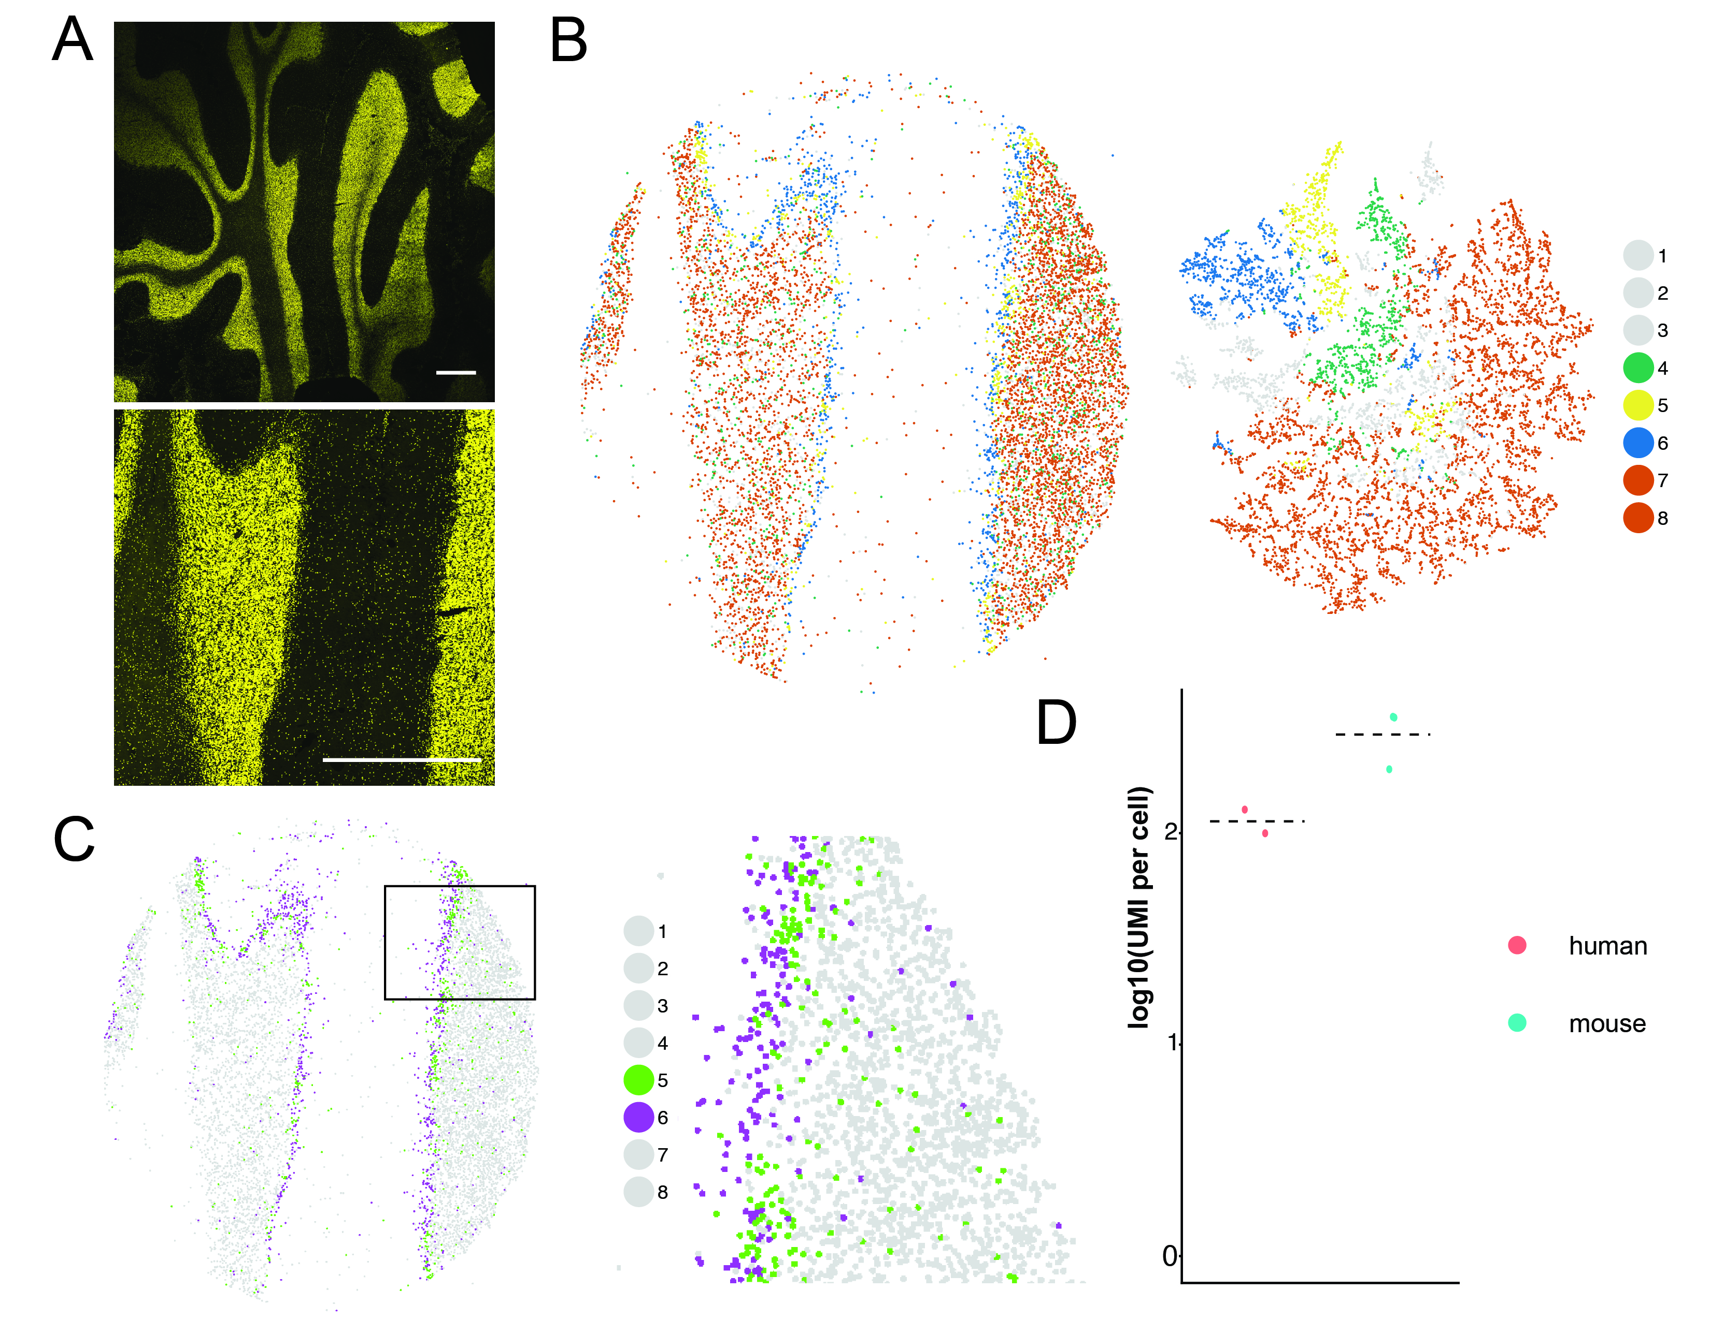

**Figure S3: (A**) Top: DAPI image of 10um section of a human cerebellum (scale bar 2 mm). Bottom: Region of the tissue placed onto a puck (white boxed region in top image, scale bar 2 mm). (**B**) Left: Slide-seq reconstruction of tissue with each bead colored by a cluster label. Right: NMF clustering of beads plotted by tSNE. Cluster identities shown: 4: Oligodendrocytes, 5: Purkinje Neurons, 6: Bergmann Glia, 7: Granular Cells, 8: Granular Cells (**C**) Left: Image in B recolored to highlight the striping pattern of Purkinje Neurons and Bergmann Glia. Right: Magnified image highlighting the alternation between beads called as Bergmann glia (purple) and Purkinje neurons (green), boxed region on left image. (**D**) Comparison of UMI counts per cell between mouse cerebellum (N = 3, 301±88 UMIs, mean ± std), and human cerebellum (N = 2, 115±21 UMIs, mean ± std ).

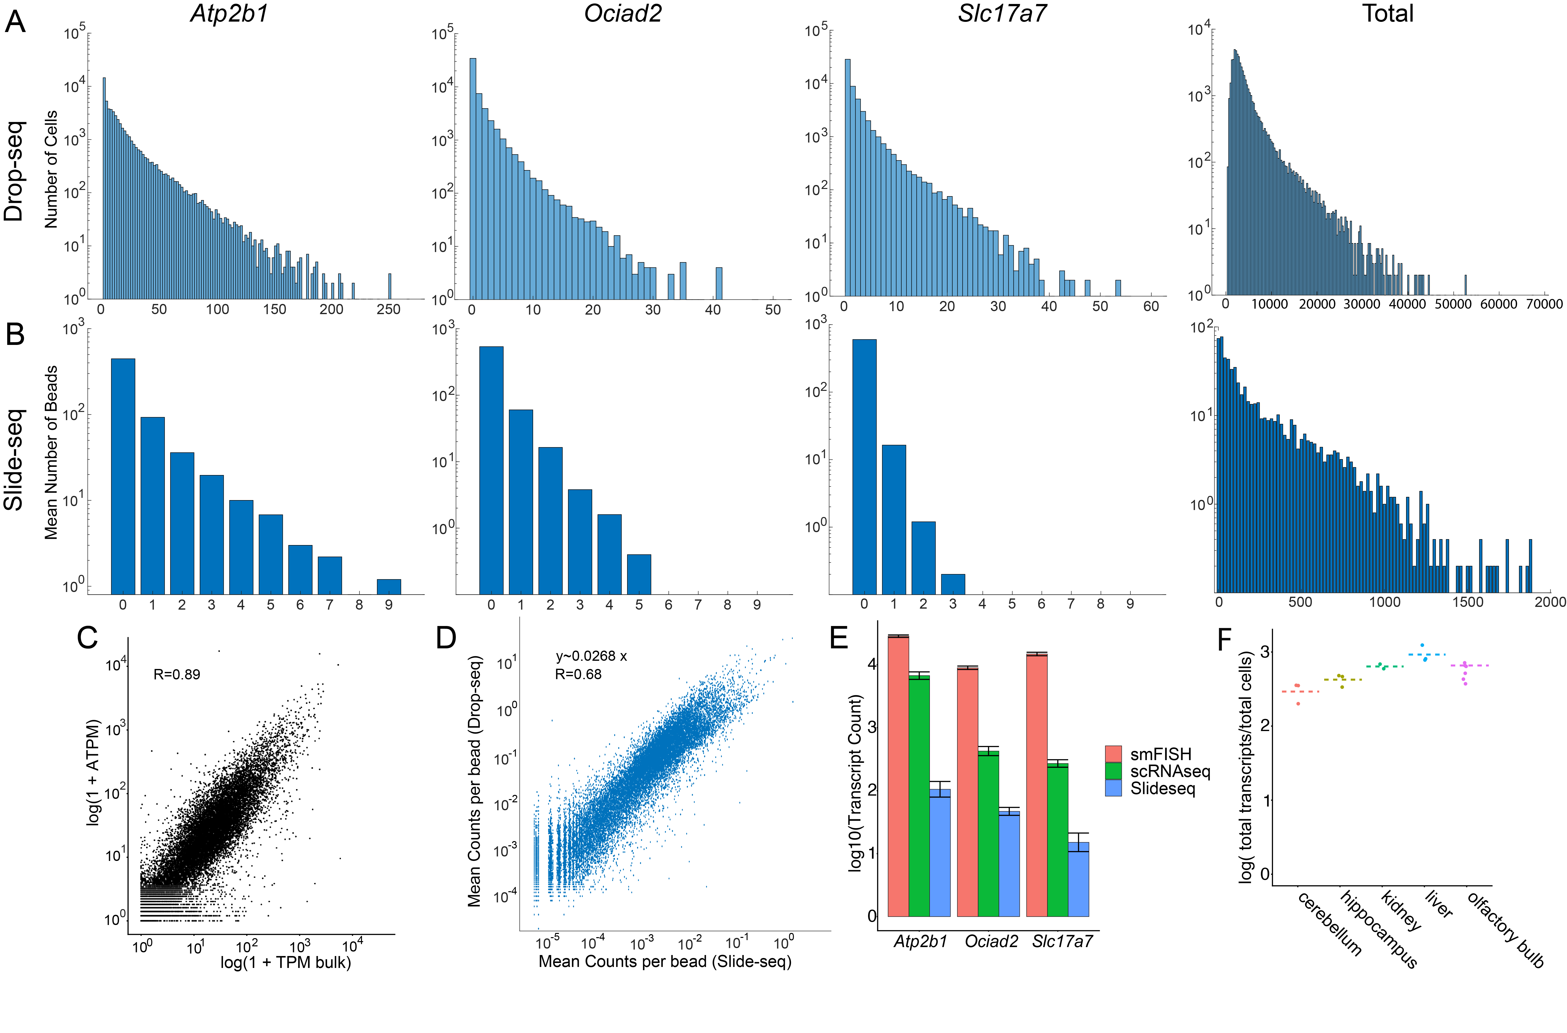

**Figure S4:** (**A**) Histograms of counts of three CA1 marker genes (left and center) and total counts (right) in Drop-seq profiles assigned to a CA1 cell identity using data from Saunders et al. (*9)* (**B**) Gene count distributions on Slide-seq beads in Fig. 2D (mean number of transcripts, averaged over five pucks from Fig 2D). (**C**) Comparison of Slide-seq expression data to bulk RNAseq. X axis represents log10(1+TPM) of bulk sagittal hippocampus RNA seq data. Y axis represents log10(1+ATPM) of Slide-seq data, see methods (R = 0.89). (**D**) For ~20,000 genes, the mean counts per cell in CA1-assigned Drop-seq beads is plotted against the mean counts per bead in CA1 Slide-seq beads. Note that although the scatterplot is displayed in log space, the fit was performed in linear space to estimate the efficiency of Slide-seq in comparison to Drop-seq. (I.e. we fit the model y~ax+b, rather than y~a x^b as is standard). A fit performed on log-adjusted transcript counts yielded an R value of 0.68. The slope of 0.0268 in the linear fit suggests that Slide-seq has 2.7% the capture of Drop-seq. (**E**) Comparison of transcript counts of three genes (*Atp2b1, Ociad2, Slc17a7)* across smFISH, scRNAseq, and Slide-seq across a field of view of CA1 (for smFISH and Slide-seq) and for the equivalent number of cells in scRNAseq. (**F**) Quantification of the number of transcripts per cell in Slide-seq data across five different tissues including hippocampus (N = 4, 427±79, mean ± std), cerebellum (N = 3, 302±88, mean± std), kidney (N = 2, 641±64, mean±std), liver (N = 3, 942 ± 255, mean ± std), and olfactory bulb(N = 6, 718±359, mean±std).

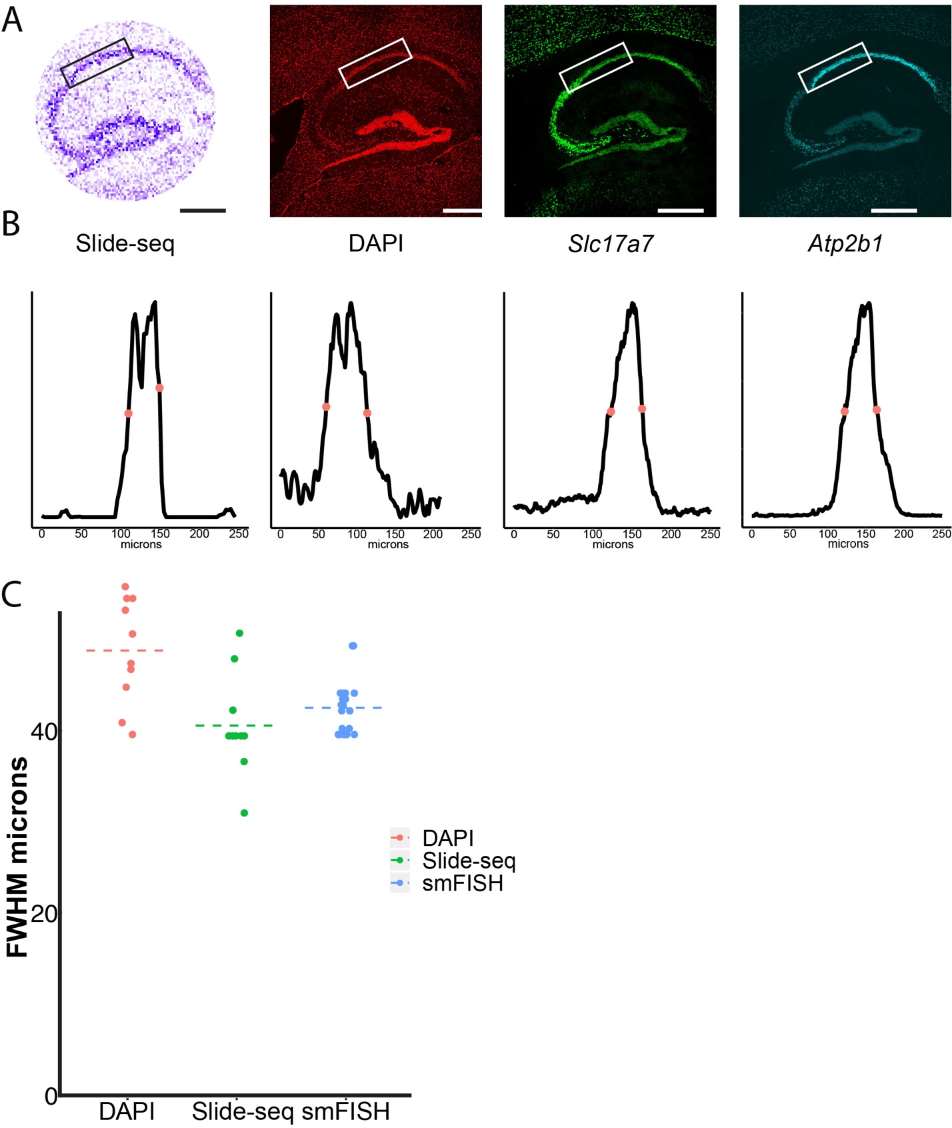

**Figure S5:** (**A**) Left: Slide-seq reconstruction of mouse hippocampus, shaded by the number of transcripts captured per bead. Middle left: DAPI image of a tissue section adjacent to the Slide-seq puck. Middle right and right: Images of smFISH staining for *Slc17a7* and *Atp2b1* from adjacent section. Box on each image represents a region taken for diffusion analysis. (**B**) Representative plots of the full width at half maximum (FWHM) for the samples above. Red dots represent the half-maximum (see Methods). (**C**) Beanplot of independent FWHM measurements of the CA1 for DAPI, Slide-seq and smFISH. Two CA1 markers were used for smFISH quantification (*Atp2b1* and *Slc17a7*). Dotted line represents mean. Scale bars: 500µm

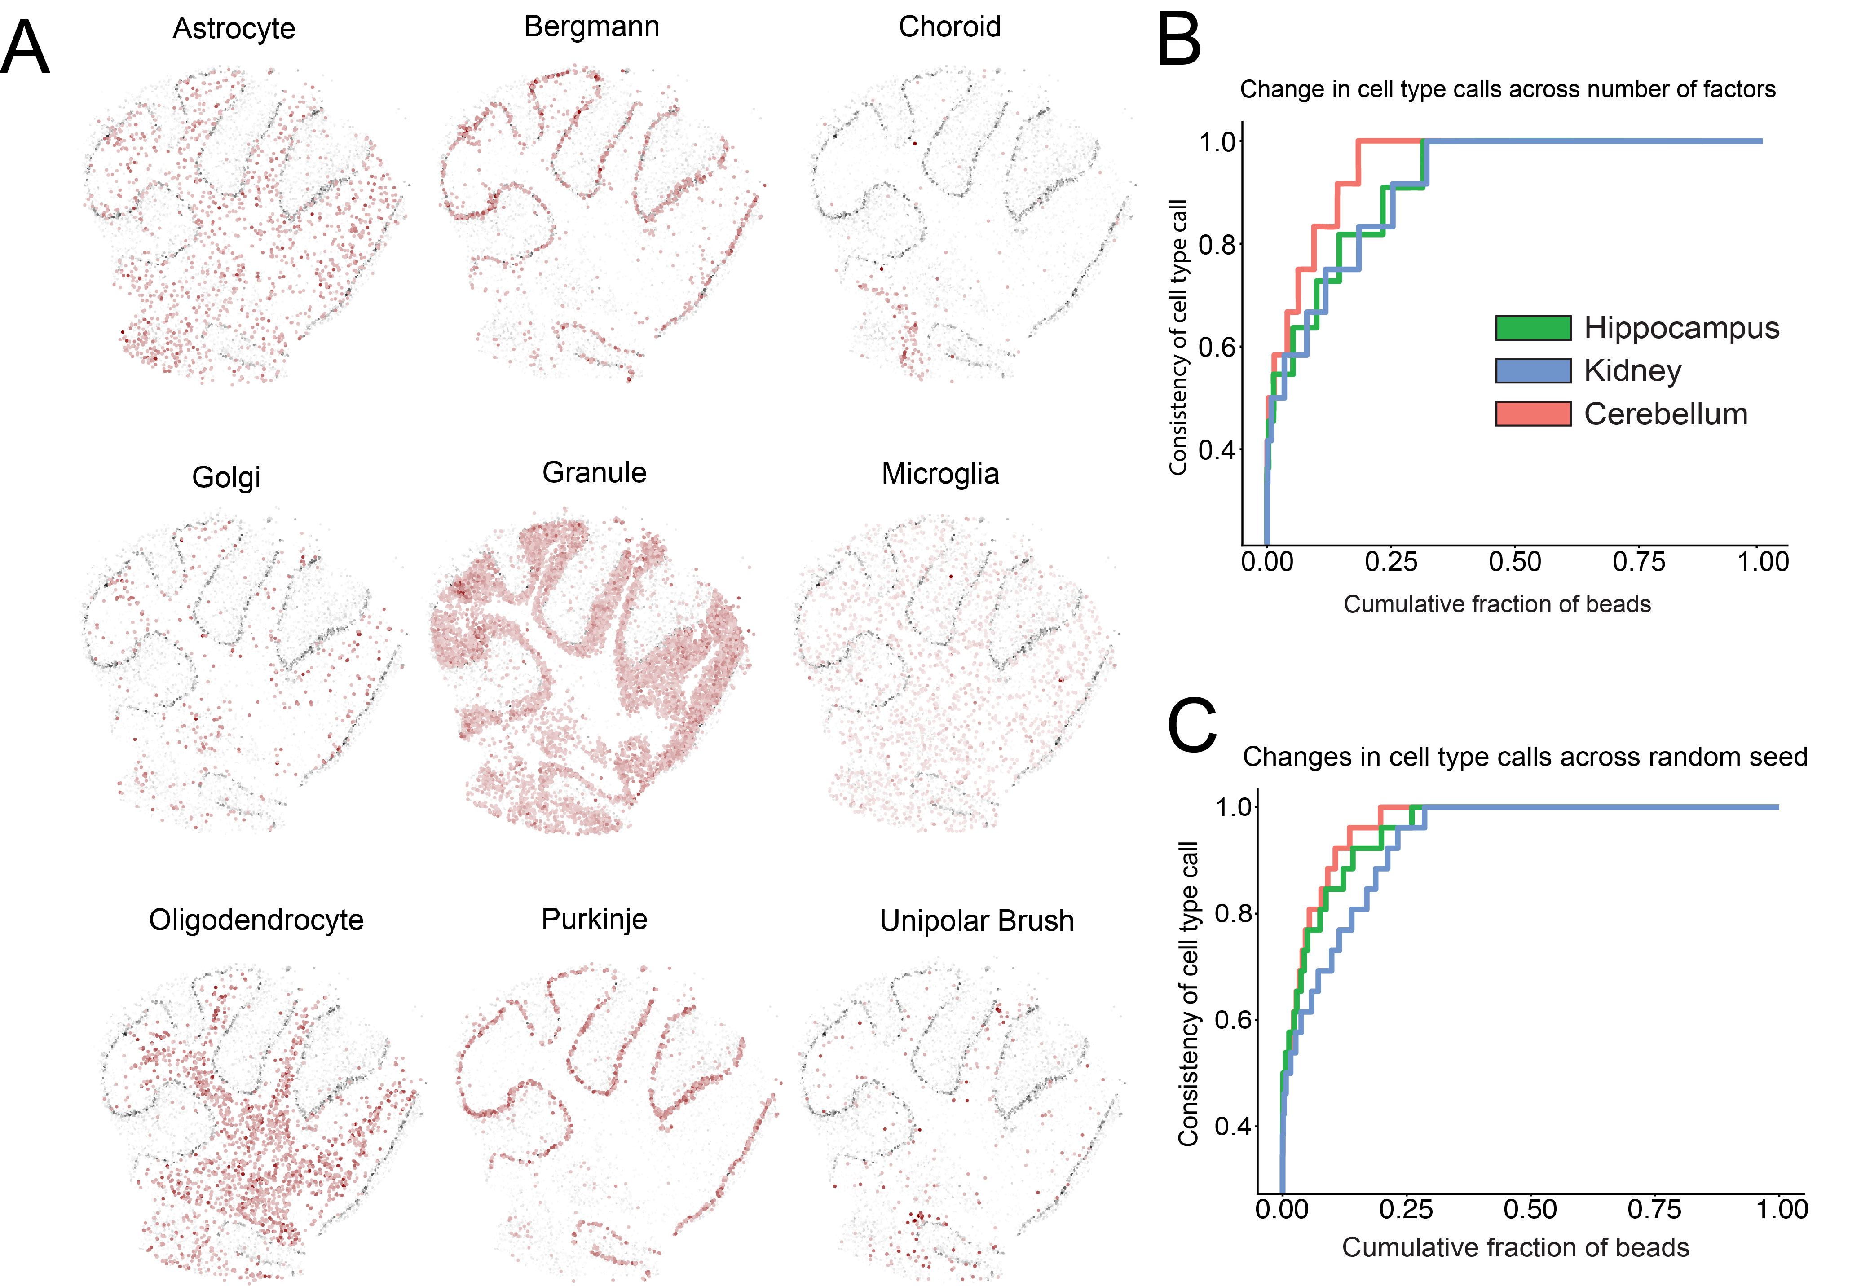**Figure S6:** (**A**) Loadings of individual cell types, defined by scRNA-seq cerebellum (*9*) on each bead, as in Fig. 2B, but for additional cell types. (**B**)Cumulative distribution plot showing the consistency in the bead identities assigned from NMFreg. The consistency is calculated by running NMFreg for 30 values of *k* (the number of factors) between 18 and 48. For each bead, the consistency is then defined as the fraction of NMFreg runs on which the bead was assigned to the modal cell type across all factors tested. Data is shown across three different tissue types. (**C**) As in B, but here the consistency is calculated by running NMFreg with 30 different random seeds.

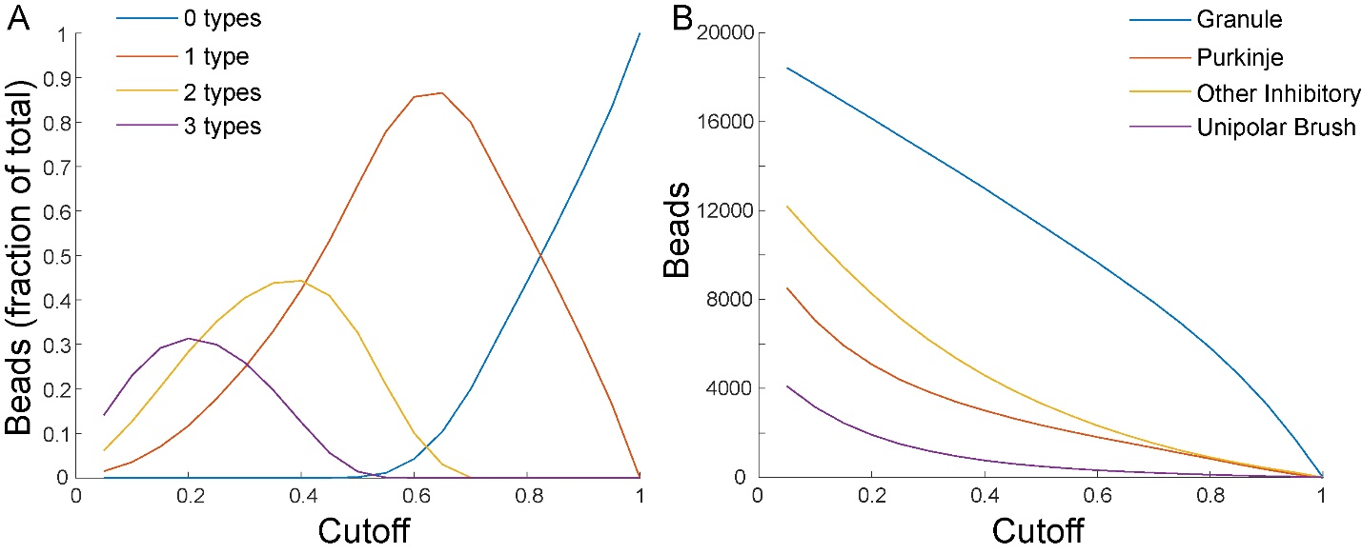

**Figure S7:** (**A**) A plot of the fraction of beads from cerebellar pucks analyzed in Fig. 2C, with zero cell types (blue), one cell type (red), two cell types (yellow), or three cell types (purple) as a function of the cutoff *C*. A cell type is defined to be present on a bead if the L2 norm of the vector of factor loadings mapping to that cell type is greater than or equal to *C* times the L2 norm of the vector of all factor loadings for that bead. For Fig. 2C, a cutoff of 0.5 was used. The plot shows mean across seven cerebellar pucks. (**B**) The mean number of beads representing granule cells (blue), Purkinje cells (red), other inhibitory neurons (yellow), and unipolar brush cells (purple) as a function of the cutoff *C*. The decrease in the number of each kind of cell is roughly linear for *C*>0.7, but is nonlinear for values of *C*<0.7, for which multiplets are possible.

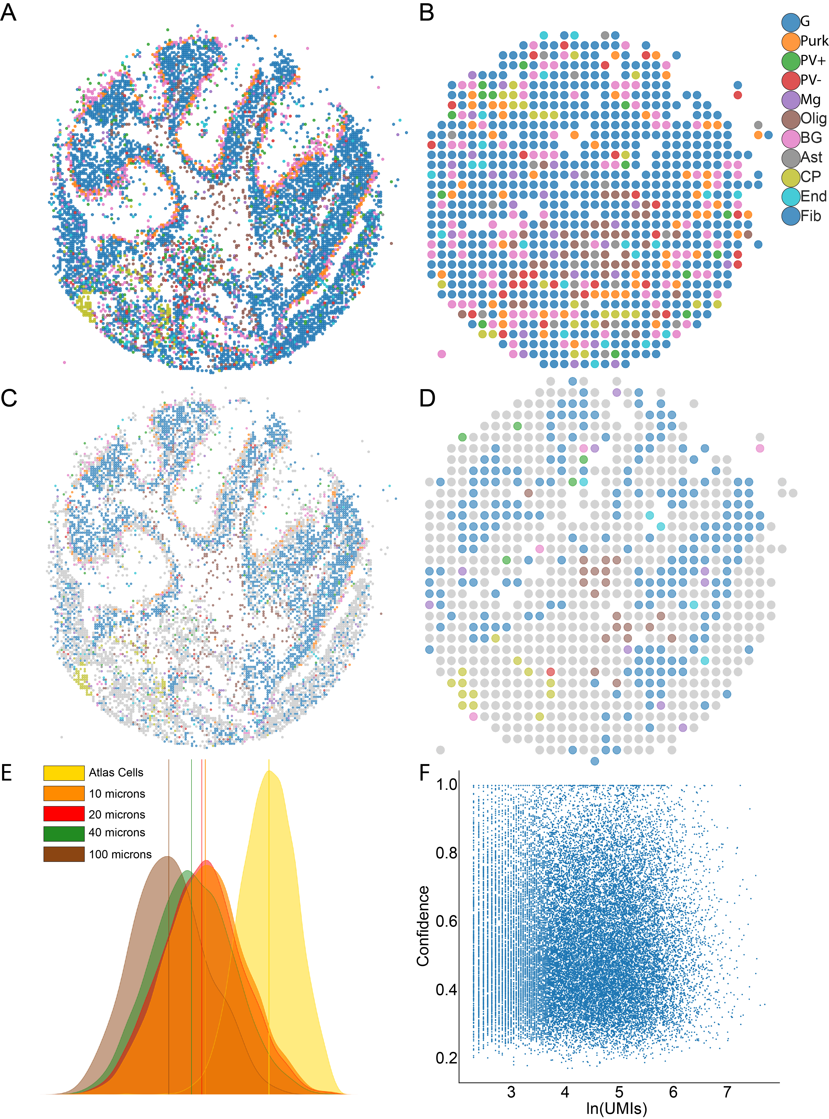

**Figure S8: Analysis** **of larger feature sizes, aggregated *in silico*.** (**A**) All beads were aggregated into 20 µm-diameter features and the resulting features were assigned cell types by NMFreg. Beads are colored according to the cluster to which they were assigned. Legend: G=Granule cells, Purk=Purkinje, PV+=Parvalbumin-positive interneuron, PV-=Parvalbumin-negative interneuron, Mg=Microglia, Olig=Oligodendrocytes, BG=Bergmann Glia, Ast=Astrocytes, CP=Choroid Plexus, End=Endothelium, Fib=Fibroblasts. (**B**) As in (A), but for 100 µm diameter aggregated features, (**C**) Same as (A), but all features that fail to pass the confidence threshold are colored in gray. (**D**) As in (C), but for 100 µm features. Upon aggregating features into 100 µm diameter features, we retain the ability to identify choroid plexus, white matter, and granule cells, but no other cell types with confidence. (**E**) The distributions of L1 norms between the factor loading distributions and the uniform distribution are shown for atlas cells, the original Slide-Seq data (10 µm), 20 µm aggregated features, 40 µm aggregated features, and 100 µm aggregated features, showing the decrease in cell type purity as the feature size increases. (**F**) The number of UMIs (natural log) versus the confidence, defined as the L2 norm of the vector of factors mapping to the cell type as which the bead was called, after normalizing so that the sum of the L2 norms for all cell types is 1. There is no relationship between the number of UMIs and the bead confidence.

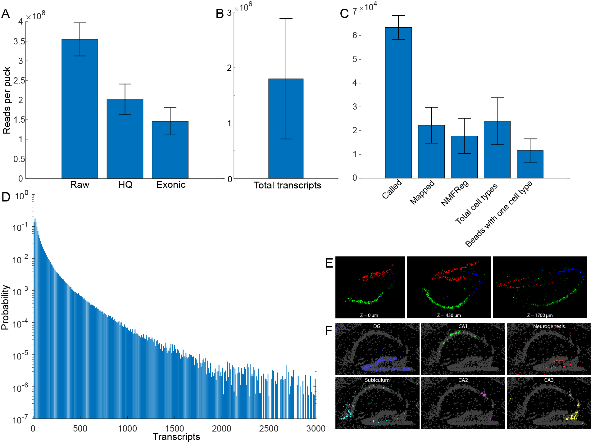**Figure S9:** (**A**)The number of raw reads, high-quality reads, and exonic reads per puck for 10 randomly selected pucks from the 66 hippocampal pucks in Fig. 2D. (**B**) The total number of transcripts per puck for the 66 hippocampal pucks in Fig. 2D. (**C**) For the 66 hippocampal pucks in Fig. 2D, from left to right, all reported on a per puck basis: the number of beads identified by SOLiD basecalling; the number of SOLiD bead barcodes mapped to Illumina bead barcodes (see “Image Processing and Basecalling”, above); the number of bijectively mapped barcodes that were processed by NMFreg (i.e., that had at least 5 variable genes); the total number of cell types passing the 0.5 L2 norm cutoff following NMFreg (Fig. S7); the number of beads with a single cell type passing the 0.5 L2 norm cutoff. (**D**) A probability density plot (i.e. normalized histogram) of the number of transcripts per bead, averaged over all 66 pucks. All error bars show standard deviation. (**E**) Cell type calls of three representative sections from the dataset with the position on the mediolateral axis denoted at the bottom of the image. (**F**) Metagene profiles on a sagittal hippocampus section representing cell subtypes.

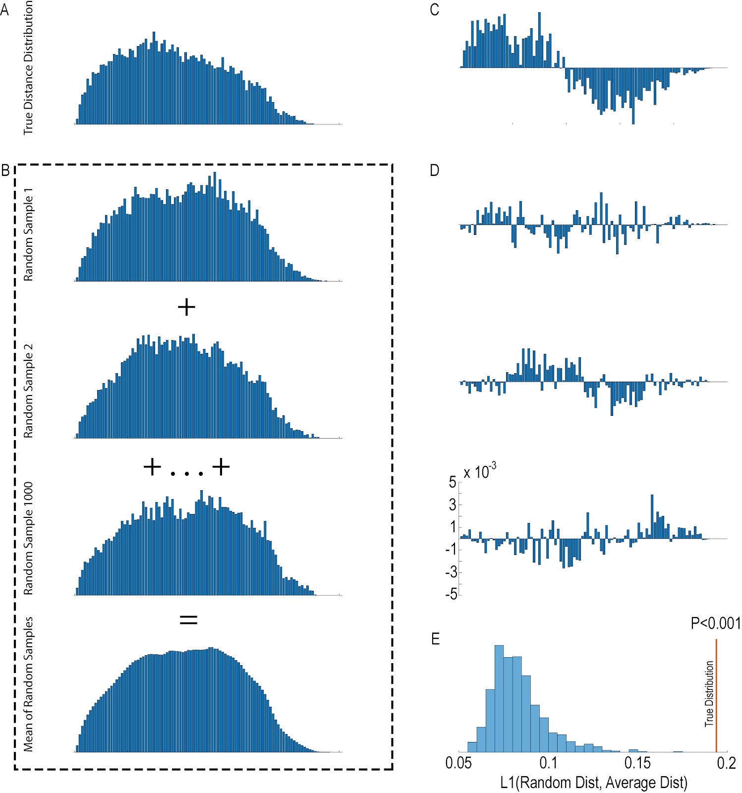

**Figure S10: Schematic of the algorithm for identifying spatially non-random genes**. The algorithm can be run on any specified subset of beads to identify genes with significant nonrandom distribution within that subset. All histograms displayed here are calculated beads defined as granule cells on a coronal cerebellar puck (Fig. 3A). **(A)** For each gene of interest, we calculate the distribution of the Euclidean distances between all beads in the specified subset expressing at least one transcript of the gene, shown here for *Rasgrf1*. **(B)** We then randomly sample an equivalent number of beads from the subset with probability proportional to the number of reads per bead, without replacement. We perform this sampling 1000 times, and for each sample, calculate the distribution of pairwise Euclidean distances between the beads thus chosen. We take the elementwise mean of all 1000 samples to obtain the average distribution of pairwise distances across random samples. **(C)** We then take the elementwise difference between the distance distribution for the gene of interest and the average distribution, **(D)** as well as between the distance distribution for each of the random samples and the average distribution. **(E)** A histogram of the sum absolute values of the distributions shown in in (D), i.e., the L1 norm between distance distributions of the random samples and of the average sample. The L1 norm serves as our test statistic: if the gene of interest is distributed proportionally to the number of transcripts per bead, the L1 norm will be uniformly distributed. For *Rasgrf1*, the L1 norm of the true distribution is greater than the L1 norms of any of the random samples, so p<0.001 (permutation test, see Methods). (Because there are only 1000 samples for reasons of computational complexity, the smallest observable p value is p<0.001).

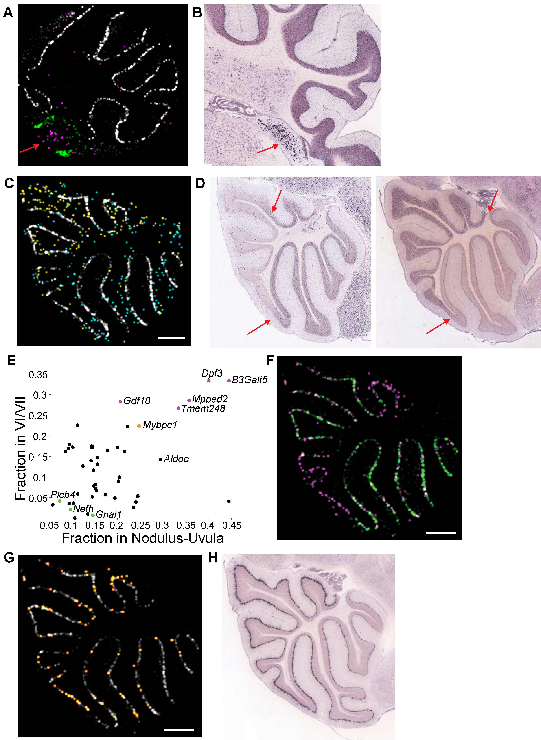

**Figure S11:** (**A**) A coronal cerebellar puck is shown, with Purkinje-assigned beads in white, choroid-assigned beads in green, and beads expressing *Ogfrl1* in magenta. Red arrow indicates cluster of *Ogfrl1*-positive beads. (**B**) An Allen Atlas (*13*) *in situ* hybridization atlas image of *Ogfrl1*, from a similar brain region. Red arrow indicates *Ogfrl1* expression in the cochlear nucleus. (**C**) A sagittal cerebellar puck showing counts of *Pcp4* (gray), *Rasgrf1* (blue), and a metagene consisting of *Gprin3*, *Cemip*, *Mab21l2*, and *Syndig1l* (yellow). (**D**) Allen atlas images of *Rasgrf1* (left) and *Gprin3* (right). Arrows indicate point of boundary of expression within the granular layer for each gene. (**E**) As in Fig. 3B, but for genes with significant expression both in the nodulus (*p*<0.05, Fisher exact test) and the VI/VII boundary (*p*<0.05, Fisher exact test). (**F**) A *Gnai1* metagene in green, and a *B3galt5* metagene in magenta. (**G**) *Mybpc1* in orange. (**H**) An Allen atlas image for *Mybpc1* (*13*). All scale bars show 250 µm; *Pcp4*, a ubiquitous marker for Purkinje cells, is in gray in (A), (C), (F), and (G). All metagenes are listed in **Table S2**.

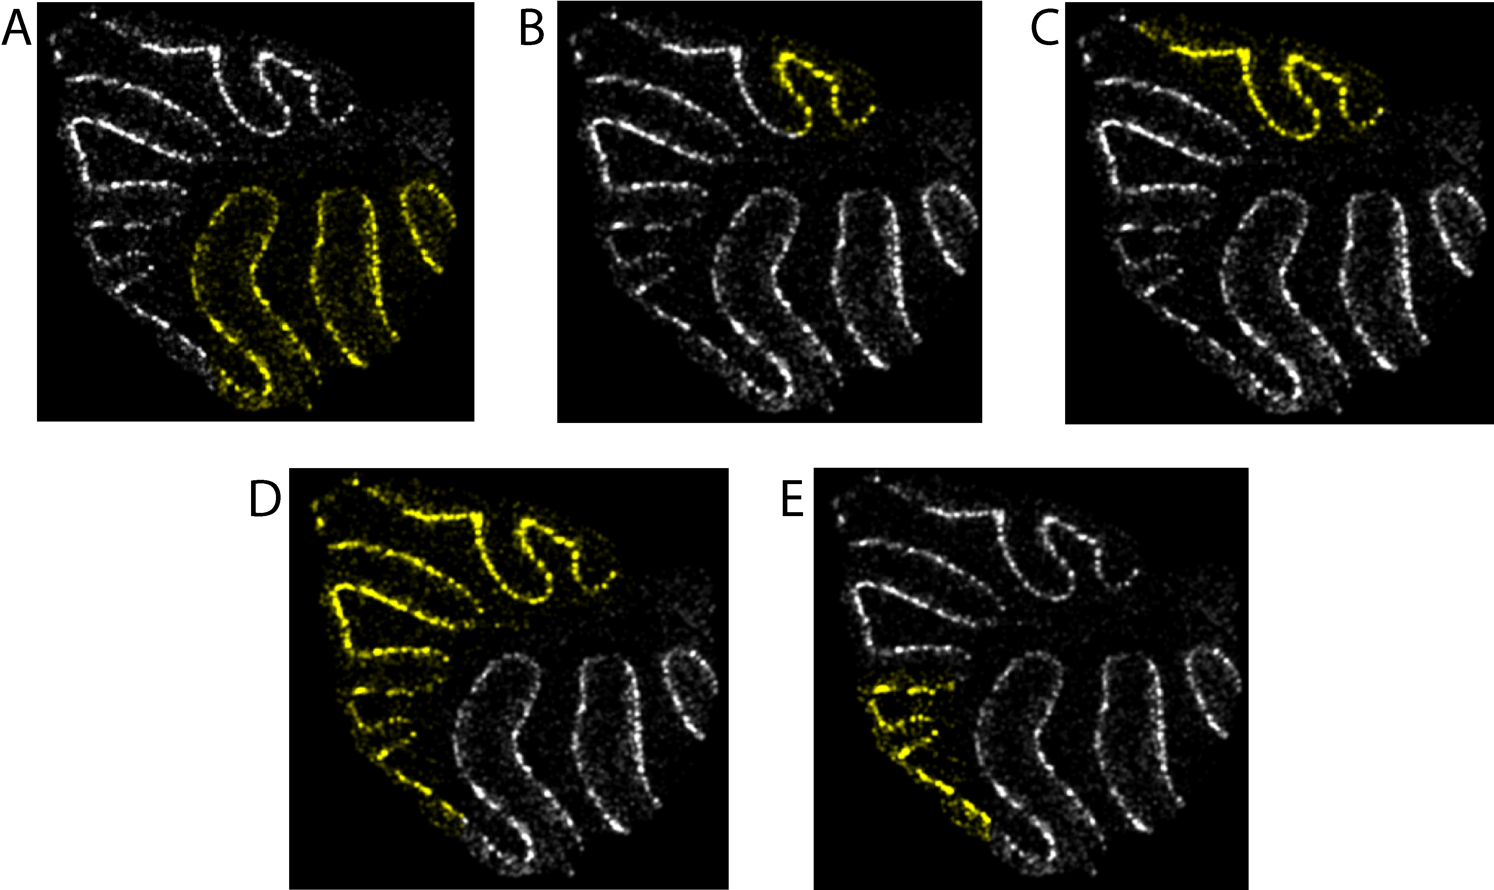

**Figure S12:** Regions chosen for analysis in Fig. 3. Yellow indicates beads included in the region designation, while white indicates beads excluded from the region. A metagene consisting of Pcp4 and Pcp2 is plotted. (**A**) The dorsal region. (**B**) The nodulus region. (**C**) The nodulus-uvula region. (**D**) The ventral region. (**E**) The VIVII region.

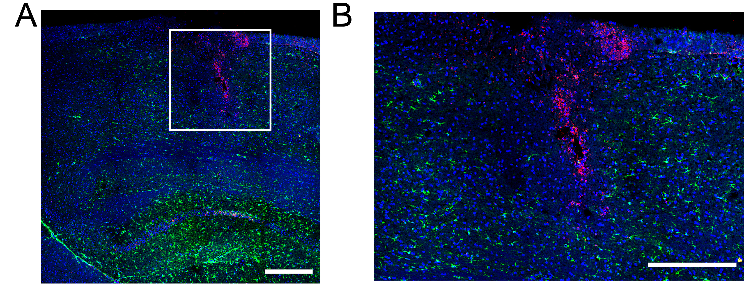

**Figure S13:** **(A)** Section of sagittal hippocampus at the site of cortical injury 3 days post injury stained with DAPI to stain nuclei (blue), *Gfap* (green), and *Vim* (magenta) revealing the precise location of the injury (white box). **(B)** Magnified image of boxed region in (A). (Scale bars: 500 μm)

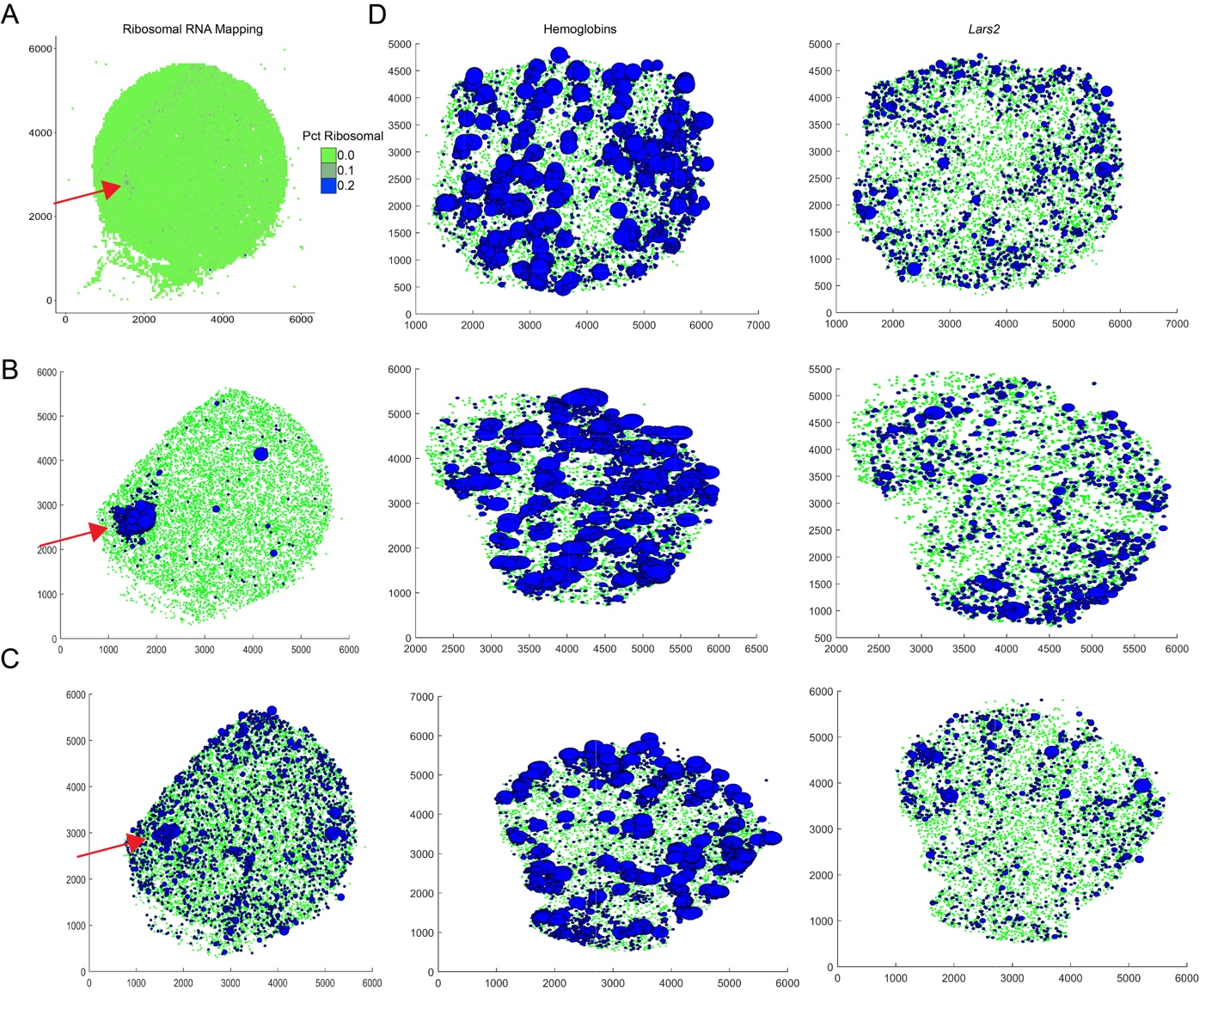**Figure S14:** (**A**) Plot showing the percentage of reads at each bead mapping to ribosomal RNA, prior to alignment, for the 180819_3 puck (same as in Fig. 4A) (**B**) Plot showing beads expressing hemoglobins. All beads expressing at least one transcript of *Hba-a1*, *Hba-a2*, *Hbb-bs*, or *Hbb-bt* are shown in blue, with radius proportional to the total number of hemoglobin transcripts. All other genes are shown in green. (**C**) As in B, but for *Lars2* transcripts, which are believed to represent rRNA. (See “Identification of rRNA in pucks” in Methods.) (**D**) Three cerebellar (non-injected) pucks, showing hemoglobin transcripts (left) and *Lars2* transcripts (right). The correlation between hemoglobin and *Lars2* in B and C is in great excess over the correlations observed in D.

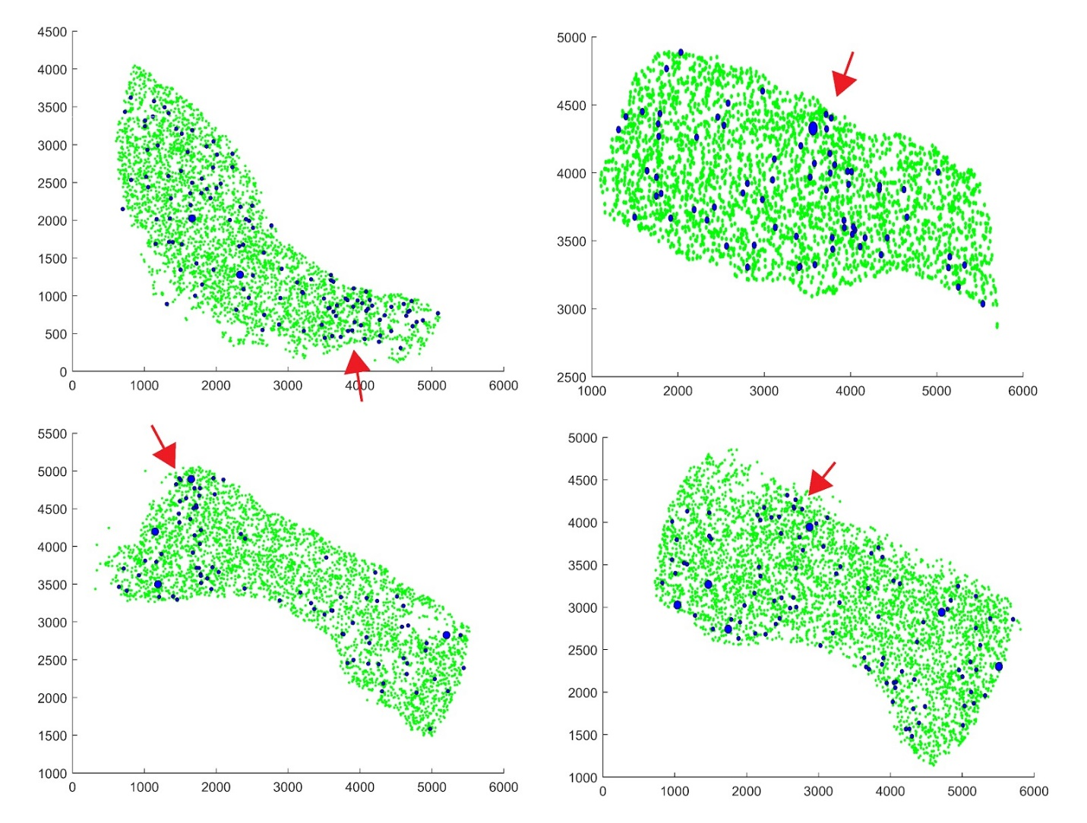

**Figure S15:** Beads expressing *Sox4* and *Sox10* are shown in blue for four pucks from the 2-week injury timepoint. The radius of blue beads is proportional to the total counts of *Sox4* and *Sox10*. The injury site is indicated with a red arrow.

**Supplementary Video 1:**

A 3D volume rendering of CA1, CA2/3 and dentate gyrus as shown in **Fig. 2**. Scale bars: 500 µm.

**Table S1:**

Oligonucleotides used in this study. Note r prior to base indicates RNA. + indicates LNA

|  |  |
| --- | --- |
| Name | Sequence |
| Truseq5 | AATGATACGGCGACCACCGAGATCTACACTCTTTCCCTACACGACGCTCTTCCGATCT |
| Smart PCR primer | AAGCAGTGGTATCAACGCAGAGT |
| Truseq_PCR_handle | CTACACGACGCTCTTCCGATCT |
| Template Switch Oligo (TSO) | AAGCTGGTATCAACGCAGAGTGAATrG+GrG |
| Truseq | /5Phos/AGATCGGAAGAGCGTCGTGTAG |
| Truseq -1 | /5Phos/GATCGGAAGAGCGTCGTCTAG |
| Truseq -2 | /5Phos/ATCGGAAGAGCGTCGTGTAG |
| TruSeq-3 | /5Phos/TCGGAAGAGCGTCGTGTAG |
| TruSeq-4 | /5Phos/CGGAAGAGCGTCGTGTAG |
| UP | /5Phos/TCTCGGGAACGCTGAAGA |
| UP-1 | /5Phos/CTCGGGAACGCTGAAGA |
| UP-2 | /5Phos/TCGGGAACGCTGAAGA |
| UP-3 | /5Phos/CGGGAACGCTGAAGA |
| UP-4 | /5Phos/GGGAACGCTGAAGA |

**Table S2:** Gene lists referenced throughout the paper, by figure.

|  |  |
| --- | --- |
| **Fig. S11C** |  |
| Genes enriched posterior of the primary fissure in the cerebellum | Gprin3, Cemip, Syndig1l, Mab21l2 |
| **Fig. 2** |  |
| Fig. 2E CA3/Hilum (plotted restricted to beads assigned by NMFreg to atlas cluster 6) | Satb1, Scg2, Nap1l5, Fxyd6, C1ql3, Necab, Slc35f1, Nrsn1, Calb2 |
| Fig. 2E CA2 (plotted restricted to beads assigned by NMFreg to atlas cluster 6) | Adcy1, Pcp4, Rgs14 |
| Fig. 2E Subiculum (plotted on all beads) | Rxfp1, Fn1, Lxn, Nr4a2 |
| Fig. 2E CA1 (plotted restricted to beads assigned by NMFreg to atlas cluster 5) | Tenm3, Lypd1 |
| Fig. 2E DG (plotted restricted to beads assigned by NMFreg to atlas cluster 4) | Mef2c |
| Fig. 2E Neurogenesis | All beads assigned to atlas cluster 13. |
| **Fig. 3** |  |
| Fig. 3C Aldocmetagene | Aldoc, Kctd12, and Car7 |
| Fig. 3C Cckmetagene | Cck, Stmn4, Kcng4, and Atp6ap1l |
| Fig. 3D H2-D1 metagene | H2-D1, Cops7a, and Kmt2c |
| Fig. 3D Hspb1 metagene | Prkci and Hspb1 |
| Fig. S11F Gnai1 metagene | Gnai1, Nefh, Plcb4, Rgs8, Homer3, Scg2, Scn4b, and Gm14033 |
| Fig. S11F B3Galt5 metagene | B3galt5, Gdf10, Tmem248, Mpped2, and Dpf3 |
| Plcb4-associated ATPases and sodium channels | Atp1a3, Atp1b1, Atp2b2, Atp6ap1l, Kcnab1, Kcnc3, Kcng4, Kcnma1.  Note that *Kcng4* is associated with increased firing rate in fast motor neurons (*34*), suggesting that its expression contributes to the faster spiking measured in Zebrin II-negative Purkinje neurons (*35*, *36*), while the calcium-dependent channel *Kcnma1* is known to regulate the timing of dendritic calcium burst spiking in Purkinje cells (*37*), suggesting that it contributes to differences in bursting activity previously observed between lobules III-V and X (*38*). |
| Example genes expressed only in lobule X | Prkci, Prkcd, Hpsb1 |
| Example genes that are expressed everywhere except in lobule X | H2-D1, Cops7a, Kmt2c |
| 669 Candidate Significant Genes | 1110001J03Rik 1700020I14Rik 1810037I17Rik 2210016L21Rik 2900093K20Rik AW047730 Abr Acin1 Actb Actr1a Actr3 Actr3b Acyp1 Adam11 Adam23 Add3 Aig1 Akap6 Akap9 Aldh5a1 Aldoc Alkbh7 Ank2 Ankrd12 Anks1b Ap1s1 Ap2a2 Aplp1 Apod Apoe App Appbp2 Ar Araf Arap2 Arfip2 Arhgap20 Arhgap5 Arl2 Arl4a Arpc4 Ascc1 Atp1a2 Atp1a3 Atp1b1 Atp1b2 Atp2b1 Atp2b2 Atp5c1 Atp5d Atp5h Atp5l Atp5o Atp6ap1l Atpif1 Atxn2 Atxn7l3b B230118H07Rik B2m Bag1 Baiap2 Bex2 Bhlhe41 Bloc1s6 Bola3 Brd7 Brd8 Brwd1 Bst2 Btbd17 Bzw1 Bzw2 Cacng2 Calb1 Calm2 Camk4 Capza2 Car2 Car7 Car8 Cbr1 Cbx6 Ccar1 Ccdc115 Ccdc50 Ccdc85b Ccdc88a Cck Cct6a Cd47 Cd63 Cd81 Cdc37l1 Cdc42ep4 Cdk5 Cdkal1 Cds2 Celf4 Cep126 Cept1 Cerk Cers4 Cggbp1 Chd9 Chga Chn1 Cisd3 Cit Ckap5 Clasp2 Cmtm5 Cnbp Cnot6l Cnp Col18a1 Commd7 Comt Copa Cops3 Cops4 Cops7a Cox14 Cox7a2l Cox8a Cpne2 Cpne9 Cr1l Creg1 Cript Cryab Csnk2a1 Cspg5 Cst3 Ctr9 Cttn Cttnbp2 Cux2 Cystm1 Cyth3 D10Jhu81e Dab1 Dagla Dap Dars Dbi Dclk1 Dcun1d5 Ddx1 Ddx42 Dgcr6 Dgkz Dnaja1 Dnajb2 Dner Dpm3 Dpp10 Dpysl2 Dstn Dtna Dync2li1 Ebf1 Echs1 Eci2 Ednrb Eif1ax Eif3a Eif3d Eif3f Eif4a1 Elmod1 Epb4.1l1 Epc1 Epha5 Ergic2 Erh Ermn Erp29 Etfa Evl Fabp3 Fabp5 Fabp7 Fam107a Fam174a Fam21 Fam98b Fbxl15 Fbxo3 Fbxo9 Fdps Fdx1 Fem1c Fgfr3 Fkbp1a Fkbp3 Fkbp8 Fth1 Fxyd7 Gabra1 Galnt11 Garnl3 Gas5 Gatm Gcsh Ggt7 Glul Gm14033 Gm27199 Gm5083 Gna13 Gnai1 Gnao1 Gnb2 Gng13 Gnl3l Golga4 Golph3 Got1 Gpatch11 Gpbp1 Gpm6b Gpr37l1 Gria1 Gria2 Gria4 Grid2 Grik1 Gsk3b Gstm1 Gtf2b Gtf2i Gucy1b3 Guk1 H2-D1 Hccs Hcfc1r1 Hdgf Hdlbp Hexa Hgsnat Higd2a Hint1 Hlf Hnrnpc Homer3 Hopx Hpcal1 Hprt Hsbp1 Hsd17b12 Hsf1 Hspa12a Hspa14 Hspa4l Hspe1 Hsph1 Hypk Icmt Id4 Ide Ifi27 Ifit3 Ifit3b Ifitm3 Ift57 Ilf2 Iltifb Ina Inpp5a Isca1 Itm2b Itm2c Itpr1 Jkamp Jrkl Kat6a Kcnab1 Kcnc1 Kcnc3 Kcnd2 Kcng4 Kcnma1 Kcnmb4 Kctd12 Khsrp Kif21a Kif3c Kif5c Kitl Klc1 Klhdc2 Kmt2c Krt25 Lamtor5 Lap3 Lars2 Ldha Lgals3bp Lhx1 Lhx1os Lin7a Lpcat4 Lpgat1 Lrrc49 Lsamp Luc7l3 Luzp2 Lztfl1 Macf1 Macrod1 Magoh Malat1 Map1a Map2k1 Map3k12 Mapk8ip2 Mapre2 Mapt March6 Mbnl2 Mbp Med8 Mef2a Meg3 Megf9 Mgst3 Mif Mipep Mir6236 Mkrn1 Mlec Mllt6 Mobp Morf4l2 Morn2 Mplkip Mrpl16 Mrpl35 Mrpl45 Mrps2 Mrps31 Msi1 Msi2 Msl3 Mt1 Mt2 Mt3 Mtdh Mtfmt Mtss1 Myo5a N6amt2 Nae1 Napg Nat8l Ncoa7 Ncor2 Ndufa11 Ndufa13 Ndufa2 Ndufa3 Ndufa4 Ndufa9 Ndufb2 Ndufb3 Ndufb4 Ndufb5 Ndufb8 Ndufb9 Ndufc1 Ndufc2 Ndufv1 Nefh Nefl Nefm Nnat Nomo1 Nop10 Npas3 Npc2 Npepps Nptx1 Npy Nr2c2 Nrsn1 Nrxn1 Nrxn2 Nsg1 Nt5c Ntrk2 Ntsr2 Nucks1 Oaz1 Oaz2 Ogfrl1 Olfm1 Omg Opa1 Opcml Opn3 Osbpl6 Ostc Pabpc1 Paip1 Pak1 Park7 Patz1 Pax6 Pbrm1 Pbx1 Pcdh17 Pcmt1 Pcp2 Pcp4 Pdcl Pde5a Pdhb Pdia3 Pdlim2 Pex13 Phip Pi4k2a Picalm Pigk Pigs Pisd Pitpnc1 Pja2 Plcb4 Plekhb1 Plekhb2 Plekhd1 Plp1 Pltp Pmm1 Pnn Pno1 Polb Polr2b Ppa1 Ppm1l Ppp1r11 Ppp1r12b Ppp1r17 Ppp2r2b Prdx1 Prdx3 Prdx5 Prdx6 Prex1 Prex2 Prkcd Prkcg Prkg1 Prkrir Prpf6 Psd2 Psma2 Psma3 Psmb10 Psmd8 Ptgds Ptpmt1 Ptpn11 Ptpn4 Ptprr Puf60 Pura Purb Pvalb Pxmp2 Qdpr Qk Rab24 Rabep1 Rabgap1l Rad23a Rad23b Ramp1 Ran Rasa2 Rasa3 Rbm5 Reep1 Rftn2 Rgs7bp Rgs8 Rims4 Riok2 Rit2 Rn18s-rs5 Rnf13 Rnf167 Rora Rpl14 Rpl18 Rpl34 Rpl38 Rpl41 Rps15a Rps21 Rps28 Rragc Rrp1 Rtfdc1 Rtn4 S100b Sac3d1 Saraf Scaf11 Sccpdh Scg2 Scn2a1 Scn4b Sdc3 Sdc4 Sdhc Senp2 Sep15 Sepp1 Sept11 Sept4 Sept7 Serbp1 Serinc1 Setd7 Sfxn4 Sigmar1 Slc13a5 Slc1a2 Slc1a3 Slc1a6 Slc24a2 Slc25a18 Slc25a39 Slc25a5 Slc33a1 Slc35a5 Slc38a1 Slc4a3 Slc4a4 Slc5a1 Smarca4 Smarcc1 Smpd1 Snap25 Snap47 Snapc3 Sncb Snhg11 Snrk Snrpn Snx24 Socs7 Sox9 Sparc Sparcl1 Spcs2 Sphkap Spock1 Spock2 Spred1 Srp9 Srsf2 Steap2 Stip1 Stk17b Stmn1 Stmn2 Stmn3 Stmn4 Strn3 Stt3b Stub1 Suclg1 Supt6 Sycp1 Syt2 Syt4 Syt7 Tardbp Tbc1d15 Tceb3 Tcf25 Tex261 Thy1 Thyn1 Timm10b Timm17b Tinf2 Tiprl Tln1 Tmed3 Tmed7 Tmeff2 Tmem11 Tmem158 Tmem167 Tmem184c Tmem255a Tmem47 Tmem50a Tmem50b Tmem64 Tmf1 Tmsb4x Tnik Tnrc6b Tomm22 Tomm40l Tpi1 Trf Trim2 Trp53bp1 Trpc3 Tsfm Tshz2 Tspan13 Tspyl4 Tst Ttc14 Ttc3 Ttl Ttyh1 Tuba1a Tubb2a Tubb2b Tubb4a Tubb5 Tulp4 U2af2 Ubap2l Ubb Ube2q1 Ube3a Ubfd1 Ubl5 Ubl7 Ublcp1 Uchl3 Ufc1 Upf2 Uqcr11 Uqcrb Uqcrh Usp14 Usp3 Usp33 Vcpip1 Vimp Vps26b Vps41 Wbp5 Wbscr22 Wdr33 Wdr7 Wwp1 Xrcc4 Ylpm1 Ywhah Zbtb20 Zcrb1 Zfc3h1 Zfp512 Zfp608 Zfp87 Zfr Zic1 Zmat2 |
| *Plcb4*-Associated Genes | Anks1b Atp1a3 Atp1b1 Atp2b2 Atp6ap1l Baiap2 Car8 Cck Cerk Chn1 Cops7a Garnl3 Gm14033 Gnai1 Golga4 Gria2 Grid2 H2-D1 Hdlbp Hnrnpc Homer3 Hpcal1 Hspa12a Icmt Ina Kcnab1 Kcnc3 Kcng4 Kcnma1 Kitl Kmt2c Lpgat1 Macf1 Mbnl2 Mef2a Msl3 Ndufb8 Nefh Nefm Nptx1 Pde5a Pja2 Plcb4 Pno1 Prdx5 Prkrir Qdpr Rabep1 Rgs7bp Rgs8 Riok2 Scg2 Scn4b Snhg11 Spock2 Stmn2 Stmn4 Strn3 Supt6 Thy1 Tmem50b Tmem64 Trim2 Tspan13 Ttc3 Vps26b Wdr7 Wwp1 Zbtb20 |
| *Aldoc*-Associated genes | Actb Aldoc Apoe Atp1a2 Atp1b2 Atp5l Atpif1 B230118H07Rik B2m Car7 Cd63 Cd81 Cdc42ep4 Cox14 Cpne9 Cst3 Dbi Dpm3 Dtna Ednrb Fam107a Fam98b Fth1 Glul Gpm6b Gpr37l1 Gria1 Gstm1 Hint1 Hopx Kctd12 Kif5c Mt1 Mt2 Mt3 Ndufa3 Ndufb4 Nomo1 Park7 Pigs Prdx6 Rpl34 Rpl38 Rpl41 S100b Sepp1 Sept4 Slc1a3 Sox9 Sparc Sparcl1 Suclg1 Tmem47 Tmsb4x Trf Tuba1a Zcrb1 |
| Genes with *p<*0.001 (Fisher exact test)in the ventral part of puck 180819_12 compared to the dorsal part, and with greater than 80% of their counts in the ventral region. | Th Cemip Gprin3 Mab21l2 Syndig1l Hbb |
| Genes with *p*<0.001 (Fisher exact test) in the nodulus-uvula region of puck 180819_12 (i.e. all genes appearing in Fig. S3B, except Kctd12 and Car7) | Aldoc Cacng4 Calm1 Calm2 Car8 Ccdc23 Cck Creg1 Cst3 Fabp7 Homer3 Hspb1 Idh3b Irs2 Malat1 Ngdn Plcb4 Prkcd Prkci Prpf31 Pvalb Rgs8 Slc1a6 Slc25a4 Sparc Stmn4 Ttr Uchl1 mt-Cytb mt-Rnr1 mt-Rnr2 |
| Genes with *p*<0.05 (Fisher exact test) in the nodulus and *p*<0.05 (Fisher exact test) in the VI/VII region of puck 180819_12 (i.e., all genes appearing in Fig. S11E). | Actb Aldoc B3galt5 Calm1 Car8 Cck Cdk5rap2 Chmp4b Cops3 Dbi Dpf3 Efr3a Eif5a Etfa Gad1 Gdf10 Gnai1 Gstm1 Homer3 Idh3g Itm2c Mpped2 Mybpc1 Nefh Nsg1 Plcb4 Ppp1r17 Pvalb Rabep1 Rgs8 Rims2 Rpl13 Sfxn1 Slc1a3 Sox9 Spock2 Timp4 Tmem248 Ttr Ufc1 Wbp2 Ywhah mt-Cytb mt-Rnr1 mt-Rnr2 |
| **Fig. 4** |  |
| Genes correlating with Vim, Ctsd, and Gfap at the 3 day timepoint. | Camk2n1 Ctsd H2-T22 Hexb Lcn2 Lgals1 Mthfd1 Slc16a11 Pvrl3 Ttr Ctss Dbi Dhrs1 Fabp7 Gfap Mgp Mrps6 Mt2 Nupr1 Pea15a Pold4 Sdc4 Smc4 Trim30a Tspo Vim Vip B2m C1qc Fam124a Fth1 Gcnt2 Gzf1 Ifi27l2a Ifitm3 Myo6 Rpl22 Serpina3n Tnfaip8 Uimc1 Usp12 Vamp8 Xaf1 Ccdc115 Igfbp2 Igfbp7 Ubap2 Eif2ak2 2010111I01Rik Ccnd1 Cnot6l Efcab14 Gbp7 Maged2 Med17 Nfkbia Pabpc1 Rgs8 Rpl10a Smc2 Ugt8a Dclk3 Rnase4 Wnt7b Plp1 Trf Irf9 Rhoc S100a16 S100a6 Srgn Actb Apod Arpc1b Bcas1 Car2 Cldn11 Cnp Cplx3 Enpp2 Ermn Fam46a Gjc3 Grb14 Id1 Id3 Ifi27 Ifit1 Ifit3 Igfbp5 Irgm1 Isg15 Itgam Itm2b Lrp4 Lta4h Mag Mal Malat1 Mbp Mgst1 Mobp Mt1 Nipbl Psmb8 Pvrl1 Rhog Siglech Tppp3 Traf7 Fgfbp3 Creld2 Kcnip2 Msl3l2 Nfkb1 Nkd1 Stat3 Abca1 Aif1 Apbb1ip C1qa C1qb Calb1 Clic1 Cpne6 Crip1 Ctsb Cx3cr1 Cyba Dcps Fcer1g Ftl1 Fyb Gm14295 Grn H2-D1 H2-K1 Hba-a1 Hba-a2 Hbb-bs Hbb-bt Heg1 Hpgd Lcorl Lgals9 Ly86 Mpeg1 Msn Myl12a Myo1c Ncf1 Nes Nfe2l2 Nptxr Pkn1 Plek Ptbp3 Pycard Rn18s-rs5 S100a11 Slc44a2 Sparc Tle1 Tuba1c Tyrobp Uaca Vcan Xpnpep3 Igfn1 Lars2 Pdlim4 Prdx6 S100a13 Sept11 Sorbs1 Syt17 Tmem176b Aco1 Agtrap Bst2 Cald1 Cd63 Cd81 Chd1l Ctdspl Gbp3 Npas3 Ptpn13 Cd52 Ilk Pou2f2 Stat1 Ybx1 Ccnd2 Ctsz Nek6 |
| Genes correlating with Vim, Ctsd, and Gfap at the 2 week timepoint. | 1500015O10Rik 1700017B05Rik 1700047M11Rik 1810058I24Rik 2610015P09Rik 2810474O19Rik 3830403N18Rik 4632428N05Rik A2m AF251705 AW112010 Abca9 Abcb1a Abcd1 Abhd12 Abhd4 Abi3 Acads Acer3 Adam10 Adam17 Adamts1 Adamtsl4 Adap2 Add3 Adgre1 Aebp1 Afap1 Aff1 Agps Ahnak Ahr Aim2 Akap12 Akap13 Aldh16a1 Aldh1a1 Aldh2 Anapc7 Ang Angpt1 Ankrd13a Anxa2 Anxa3 Anxa4 Anxa5 Aplp1 Apobec1 Apobec3 Apoc1 Apoe Aqp4 Arap1 Arhgap17 Arhgap29 Arhgap30 Arhgdib Arrdc4 Arvcf As3mt Ascc2 Aspa Atf3 Atp1a2 Atp1b3 Atp6v0e Axl Bach1 Bcl2a1b Bfsp2 Bgn Bhlhe41 Bin1 Bin2 Blvrb Bmp2k Brd7 Bri3 Btg1 C3ar1 C4b Calr Capg Capns1 Carf Carhsp1 Casp8 Cav2 Ccdc13 Ccdc50 Ccdc74a Ccl3 Ccl4 Ccl5 Ccl6 Ccl9 Ccpg1os Cd14 Cd151 Cd164 Cd180 Cd302 Cd37 Cd44 Cd48 Cd53 Cd68 Cd74 Cd82 Cd83 Cd84 Cd86 Cd9 Cdc42ep4 Cdc42se1 Cdkn1c Cebpa Cebpg Cela1 Cenpb Cfh Cflar Cgnl1 Ch25h Chd4 Chst2 Clec5a Clec7a Clic4 Clmp Clu Cnn3 Cntrl Col12a1 Col1a1 Col1a2 Col27a1 Col3a1 Col4a2 Col5a1 Col6a1 Col9a3 Colec12 Colgalt1 Commd10 Coro1b Cotl1 Cpe Cped1 Cpne3 Cpq Cpt1a Cpxm1 Creg1 Crlf2 Crot Cryab Cryba4 Csf1 Csf1r Csf2rb Csrp1 Cst3 Cst7 Cstb Ctdsp2 Ctnna1 Ctnnb1 Ctsa Ctsc Ctsh Ctsk Ctsl Cttnbp2nl Cxcl14 Cxcl16 Cyb5r3 Cybb Cyfip1 Cyp4f14 Cyth3 Cyth4 Dab2 Dcn Ddah2 Ddr1 Diap2 Dio2 Dnase2a Dnm2 Dock1 Dock10 Dpp7 Dtx3l E130114P18Rik Edem1 Edn3 Ednrb Eef1a1 Eef1d Eef2 Ehd4 Eif3a Elf1 Elk3 Emid1 Eml4 Emp3 Endod1 Entpd1 Epas1 Epb4.1l2 Erbb2ip Erp44 Eya3 Ezr F11r Fabp5 Fam107a Fam114a1 Fam114a2 Fam46c Fblim1 Fbln1 Fbn1 Fcgr1 Fcgr2b Fcgr3 Fcho2 Fcrls Fermt3 Fgfr1 Fkbp7 Fli1 Flt1 Fmnl2 Fn1 Fnbp1 Fnip2 Foxc1 Foxo4 Frmd4a Fstl1 Fuca1 Fxyd1 Fxyd5 Gabarap Galnt10 Gatm Gbp2 Gcn1l1 Ghdc Gjb2 Gltp Glul Gm13139 Gm2a Gm973 Gna12 Gnai2 Gnb2l1 Gng12 Gng5 Gngt2 Gns Golim4 Golm1 Gpm6b Gpnmb Gpr183 Gpr34 Gpr37 Gpt Gpt2 Gpx1 Gsap Gsn Gstm1 Gstp1 Gucd1 Gusb Gyg H2-Aa H2-Ab1 H2-DMa H2-Eb1 H2-T23 H3f3b Hbegf Hdlbp Hes6 Hexa Hist1h1c Hist1h2bc Hk2 Hmha1 Hmox1 Hpgds Hrsp12 Hsd17b11 Hsd3b7 Hsp90b1 Hspb6 Hspb8 Hvcn1 Ifi30 Ifi35 Ifih1 Ifit2 Ifit3b Ifitm2 Ifnar1 Ifnar2 Ifngr1 Igbp1 Igf1 Igf2 Igfbp3 Ikbkb Il10rb Il21r Il33 Il6st Inpp5d Inppl1 Ipo8 Iqce Iqgap1 Irf8 Islr Itga6 Itgav Itgb1 Itgb3bp Itgb5 Itih5 Kcnj10 Kctd12 Kctd5 Kdm5a Kif5b Klf2 Klhl36 Klhl5 Klk6 Krcc1 Lactb Lactb2 Lair1 Lamb1 Lamb2 Lamc1 Lamp1 Lamp2 Lap3 Laptm4a Laptm5 Lat2 Lats2 Lcp1 Lgals3 Lgals3bp Lgmn Lhfpl2 Lilrb4 Lima1 Limch1 Lipa Lmo2 Lpar1 Lpcat1 Lpl Lrp10 Lsp1 Lsr Ltbr Ly6e Lyn Lyz2 Maf Mafb Magoh Magt1 Maml2 Man2b1 Map4k4 Marcks Matn4 Mcl1 Mdk Metap2 Mfap1b Mlc1 Mmp14 Mob1a Mob3b Mob3c Mog Mrpl52 Ms4a6c Msx1 Mt3 Mtdh Myh9 Mylip Myo18a Myo1f Myo9b Myoc Myof Naglu Nagpa Nbl1 Ncf2 Nckap1l Ncl Ndrg1 Neat1 Nek7 Nek9 Nfe2l3 Nfia Nhlrc3 Npc2 Npm1 Nrp1 Nrp2 Ntpcr Oard1 Oat Olfml1 Olfml3 Olig1 Opalin P2rx4 P2ry12 P2ry13 P4hb Pacsin3 Padi2 Palld Parp3 Pbrm1 Pbx3 Pbxip1 Pdcl Pde3b Pdgfra Pdia3 Pdlim2 Pdlim5 Pdpn Pex19 Pfn1 Phkg1 Phldb1 Phldb2 Pla2g15 Pla2g16 Pla2g7 Pld4 Plekhb1 Plekhf2 Plgrkt Plin2 Pllp Plod3 Pltp Plvap Plxdc2 Plxnb2 Pmp22 Ppap2b Ppfibp2 Ppp1r14b Ppp1r18 Prdx1 Prex1 Prex2 Prkcd Psap Psen1 Psme2b Ptgds Ptma Ptn Ptp4a2 Ptpn1 Ptpn18 Ptpn6 Ptprb Ptprc Ptprz1 Ptrf Ptrh1 Qdpr Qk Rab3il1 Rac2 Rad9a Ramp2 Rarres2 Rasgrp3 Rassf2 Rassf4 Rbms1 Rcan3 Rcn3 Reep3 Rel Renbp Rest Rgl2 Rgs10 Rgs5 Rhoa Rhoj Rhoq Rlbp1 Rnaset2a Rnaset2b Rnf130 Rnf141 Rnf213 Rock1 Rpl13a Rpl18 Rpl18a Rpl23 Rpl26 Rpl32 Rpl35a Rpl37 Rpl37a Rpl39 Rplp0 Rplp1 Rplp2 Rps10 Rps11 Rps14 Rps15a Rps20 Rps24 Rps26 Rps27l Rps3 Rps5 Rps9 Rras Rrbp1 Rtp4 Rufy1 Runx1 S100a1 S100a10 S100a4 S100b Sall1 Samd9l Samhd1 Samsn1 Sat1 Scamp2 Scara3 Scarb2 Scd1 Scd2 Scpep1 Scrg1 Sdc3 Selplg Sepp1 Sept10 Serinc3 Serpinb9 Serpine2 Serpinf1 Serpinh1 Sfrp4 Sgk1 Sgpl1 Sh3bp2 Sh3d19 Sh3glb1 Sh3pxd2a Sirpa Sirt2 Slain2 Slc11a1 Slc12a2 Slc14a1 Slc15a3 Slc16a1 Slc16a2 Slc1a2 Slc1a3 Slc25a10 Slc25a15 Slc25a18 Slc26a2 Slc29a3 Slc38a6 Slc39a1 Slc44a1 Slco2b1 Slfn5 Smarca5 Smg8 Smim3 Snhg18 Snx18 Snx5 Soat1 Sowahc Sox10 Sox12 Sox4 Sp1 Sp100 Sparcl1 Spata13 Spi1 Spp1 Spsb1 Sspn St3gal6 Stat2 Stat6 Stx2 Sulf1 Sult1a1 Susd6 Svil Tab2 Tagln2 Tap2 Tapbp Tcirg1 Tead1 Tec Tep1 Tgfb1 Tgfb2 Tgfb3 Tgfbr1 Tgfbr2 Tgif1 Thbd Thbs2 Thbs4 Timp1 Timp2 Timp3 Tlr3 Tm4sf1 Tmed10 Tmed3 Tmed5 Tmem119 Tmem123 Tmem150a Tmem170b Tmem176a Tmem18 Tmem47 Tmem86a Tmsb4x Tmtc2 Tnfaip8l2 Tnfrsf1a Tnni1 Toporsos Tpm2 Tpm3 Tpm4 Tpp1 Tpr Trem2 Trex1 Trim12a Trim25 Trim56 Trip11 Trp53i13 Tsc22d4 Tspan2 Tspan4 Ttc28 Ubald2 Ucp2 Unc93b1 Usp25 Ust Vamp5 Vasp Vat1 Vgll4 Vkorc1 Vps54 Vtn Wapal Wasf2 Wfdc17 Wipf1 Wls Wnk1 Wnt5a Wrn Wsb1 Wwtr1 Xlr Ybx3 Zbtb20 Zc3hav1 Zeb2 Zfhx3 Zfp36l1 Zfp703 Zic1 Zmiz1 Znfx1 Abca1 Actb Agtrap Aif1 Apbb1ip Apod Arpc1b B2m Bcas1 Bst2 C1qa C1qb C1qc Cald1 Car2 Ccnd1 Ccnd2 Cd52 Cd63 Cd81 Cldn11 Clic1 Cnp Crip1 Ctsb Ctsd Ctss Ctsz Cx3cr1 Cyba Dbi Dhrs1 Eif2ak2 Enpp2 Ermn Fabp7 Fam46a Fcer1g Fth1 Ftl1 Fyb Gbp3 Gcnt2 Gfap Grb14 Grn H2-D1 H2-K1 Hexb Id1 Id3 Ifi27 Ifi27l2a Ifit1 Ifit3 Ifitm3 Igfbp2 Igfbp5 Igfbp7 Itgam Itm2b Lcn2 Lgals1 Lgals9 Ly86 Mag Mal Malat1 Mbp Mgp Mgst1 Mobp Mpeg1 Mrps6 Msn Mt1 Mt2 Myl12a Myo6 Ncf1 Nek6 Nfe2l2 Nfkb1 Nfkbia Nupr1 Pabpc1 Pdlim4 Pea15a Plek Plp1 Pold4 Pou2f2 Prdx6 Psmb8 Ptbp3 Pycard Rhoc Rhog Rnase4 Rpl22 S100a11 S100a13 S100a16 S100a6 Sdc4 Serpina3n Siglech Sparc Stat1 Stat3 Tmem176b Trf Trim30a Tspo Ttr Tyrobp Uaca Vamp8 Vcan Vim Ybx1 |
| Immediate early genes that were observed to be upregulated around the injury site at 3 days and 2 weeks | Fos, Arc, Npas4, Junb |
| Genes that correlate with Fos, Arc, Npas4, and Junb in the overlap analysis at the 2 week timepoint | Egr1, Egr4, Lmo4, Nr4a1, Slc16a13, Rgs4, Grin2b, C1ql3 |
| Fig. 4K metagene | Fos, Arc, Npas4, Junb, Egr1, Egr4, Lmo4, Nr4a1, Slc16a13, Rgs4, Grin2b, C1ql3 |

**Table S3:**

|  |  |
| --- | --- |
| **Figure** | **Pucks used** |
| 1C | 180413_7 (coronal hippocampus) |
| 1D | 180430_1(coronal cerebellum), 180528_23 (kidney), 180803_8 (liver), 180430_3(coronal olfactory bulb) |
| 2B | 180430_6 (coronal cerebellum) |
| 2C | 180819_9 (sagittal cerebellum), 180819_10 (sagittal cerebellum), 180819_11 (sagittal cerebellum), 180819_12 (sagittal cerebellum), 180430_1 (coronal cerebellum), 180430_5 (coronal cerebellum), 180430_6 (coronal cerebellum) |
| 2D | 180528_20, 180528_22, 180531_13, 180531_16, 180531_17, 180531_18, 180531_19, 180531_22, 180531_23, 180602_15, 180602_16,  180602_17, 180602_18, 180602_20, 180602_21, 180602_22, 180602_23, 180602_24, 180611_1, 180611_2 (sagittal hippocampus) |
| 3A | sagittal cerebellum: 180819_9, 180819_10, 180819_11, 180819_12, 180819_24, 180819_26, 180819_30, 180821_8, 180821_9, 180821_12. coronal cerebellum: 180430_1, 180430_5, 180430_6 |
| 3B-D | 180819_12 (sagittal cerebellum) |
| 4A | 180819_3 (coronal cortex) |
| 4B | 180819_19 (sagittal cortex) |
| 4C | 180819_6 (sagittal cortex) |
| 4D | 180819_19 (sagittal cortex) |
| 4E | 180819_6 (sagittal cortex) |
| 4F | All sagittal cortex: 180819_5, 180819_6, 180819_7 (AS, MP, MM); 180819_19, 180821_3 (ML) |
| 4G-J | All sagittal cortex: 180819_19 (top), 180819_6 (bottom). See Methods for a list of pucks used to determine the list of genes used for GO analysis in Fig. 4G-J. |
| 4K | All sagittal cortex: 180819_5 (top), 180819_6 (bottom) |
| S1D (left) | 180413_7 (coronal hippocampus) |
| S1D (right) | 180819_3, 180819_4, 180819_5, 180819_6, 180819_7, 180819_8, 180819_9, 180819_10, 180819_11, 180819_12 (NA, beads counted on surface) |
| S1E | 180611_6 (sagittal hippocampus) |
| S2 | 180430_1 (coronal cerebellum), 180413_7(coronal hippocampus), 180528_23 (kidney), 180803_8(liver), 180430_3(olfactory bulb) |
| S3B,C | 180821_27 (coronal human cerebellum) |
| S3D | 180430_1 (coronal cerebellum),180430_5 (coronal cerebellum), 180430_6 (coronal cerebellum),180821_27 (human cerebellum coronal), 180821_28 (human cerebellum coronal) |
| S4B | 180620_4, 180531_17, 180602_20, 180531_13, 180531_22 (sagittal hippocampus) |
| S4C | 180620_4, 180531_17, 180602_20, 180531_13, 180531_22 (sagittal hippocampus) |
| S4D | 180602_17,180602_20,180611_6 (sagittal hippocampus) |
| S5A | 180602_20 (sagittal hippocampus) |
| S6A | 180430_6 (coronal cerebellum) |
| S6B | 180430_6 (coronal cerebellum), 180413_7 (coronal hippocampus),180528_23 (Kidney) |
| S7 | 180819_9 (sagittal cerebellum), 180819_10 (sagittal cerebellum), 180819_11 (sagittal cerebellum), 180819_12 (sagittal cerebellum), 180430_1 (coronal cerebellum), 180430_5 (coronal cerebellum), 180430_6 (coronal cerebellum) |
| S8A-D | 180430_6 (coronal cerebellum) |
| S8E | 180430_6 (coronal cerebellum) |
| S8F | 180430_6 (coronal cerebellum) |
| S9A,B | 180602_16, 180602_17, 180602_18, 180602_20, 180618_4, 180618_7, 180618_12, 180618_13, 180618_14, 180618_15 (sagittal hippocampus) |
| S9C,D | 180528_20, 180528_22, 180531_13, 180531_16, 180531_17, 180531_18, 180531_19, 180531_22, 180531_23, 180602_15, 180602_16,  180602_17, 180602_18, 180602_20, 180602_21, 180602_22, 180602_23, 180602_24, 180611_1, 180611_2, 180611_3, 180611_4, 180611_5, 180611_6, 180611_7, 180611_8, 180611_9, 180611_10, 180611_11, 180611_12, 180611_13, 180611_14, 180611_16, 180615_1, 180615_3, 180615_4, 180615_5, 180615_6, 180615_7, 180615_8, 180615_10, 180615_11, 180615_12, 180615_14, 180615_16, 180615_17, 180615_18, 180615_20, 180615_21, 180615_22, 180618_3, 180618_4, 180618_7, 180618_12, 180618_13, 180618_14, 180618_15, 180618_16, 180618_18, 180618_20, 180618_21, 180618_24, 180620_1, 180620_3, 180620_4, 180620_5  (sagittal hippocampus) |
| S10 | 180430_6 (coronal cerebellum) |
| S11A | 180430_6 (coronal cerebellum) |
| S11C,E-G | 180819_12 (sagittal cerebellum) |
| S12 | 180819_12 (sagittal cerebellum) |
| S14A-C | 180819_3 (coronal hippocampus) |
| S14D | 180430_1, 180430_5, 180430_6 (sagittal cerebellum) |
| S15 | 180819_5 (top left), 180819_6 (bottom left), 180819_7 (top right), 180819_8 (bottom right) |